

CECS 551 ARTIFICIAL INTELLIGENCE

Artificial Intelligence (AI) Approach in Retail Market Analysis and Growth

<Final Report>

***Group: 6* *Supervisor***

* Ankit Ramrakhyani (029371899) Dr. Mahshid Fardadi
* Aparna Popade (026735460)
* Sarthak Jariwala (029341388)
* Shruthi Venkatchalam (029395663)
* Devansh Goel (029362552)

~ FALL 2022 ~

Contents

**1. Introduction 4**

**1.1 Dataset 01 Description 5**

**1.2 Dataset 02 Description 6**

**A) Sprint 1 7**

**2. Dataset 01 7**

**2.1 Problem Statement 7**

**2.2 Final Dataset Visualization: 7**

**2.3 Google Colab URL 25**

**3. Dataset 2 25**

**3.1 Problem Statement 25**

**3.2 Final Dataset Visualization 26**

**B) Sprint 2 30**

**4. Dataset 1 30**

**4.1 Problem Statement 30**

**4.2 Final Dataset Visualization: 30**

**4.4 Colab Link 44**

**5. Dataset 2 45**

**5.1 Problem Statement 45**

**5.2 Final Dataset Visualization 45**

**5.3 Colab Link 67**

**C) Sprint 3 68**

**6. Dataset 2 68**

**6.1 Deploy the machine learning model using Streamlit 68**

**6.2 Product Segmentation 68**

**6.3 Colab Link 76**

**7. Conclusion 76**

**Abstract**

The project entails analyzing inventory data of two datasets of around more than 30 stores of an international retail business. It is designed to implement two-week sprints of the scrum process, mimicking a real tech company software development and machine learning work environment. The purpose of the analysis is to use the inventory data to improve sales, resulting in a more efficient operation.

Dataset 01: The task is to predict the department-wide sales for each store in a week using regression. For the second part, the task is to predict the type of store using classification.

Dataset 02: For Sprint2, the target was to visualize the daily, monthly, and total sales in STATE1 and STATE2. We also had to identify the department with the highest and lowest sales across all stores. Then we had to determine the product sales and availability over time in each store, and average price on each category. The final task was to Visualize the monthly and total sales for each store and each category. Identify the most sold products in each state in each department and then finally investigate the average sales of highly sold products for a given price of each month and on weekdays, and average sales on event types, for example, cultural, national, etc.

# 1. Introduction

For Dataset 01, the task is to predict the department-wide sales for each store in a week using regression. For the second part, the task is to predict type of the store using classification.

For dataset 02, we came up with methods to carryout data preprocessing and Exploratory Data Analysis. For bonus points, we took efforts to perform downcasting the dataset size. We have also performed hyperparameter optimization using Long short-term memory (LSTM) layer in Tensorflow.

During the relevant sprint, we delivered the dataset to the team members and made an effort to complete the project's second milestone on time. The accompanying table shows what each team member provided as a result.

|  |  |  |
| --- | --- | --- |
| **Name** | **Dataset** | **Role and Contribution** |
| Aparna Popade | 1, 2 | * Coding for dataset 1 sprint 1,2. * Deployment for dataset 2 in Sprint 3. * Helped Devansh for Report and presentation part |
| Ankit Ramrakhyani | 1 | * Presentation and Report for Dataset1 for all Sprint. * Coding for part 1 of dataset 1 in Sprint 2 |
| Shruthi Venkatchalam | 2 | * Coding (complete tableau analysis) for dataset 2 in sprint 1. * PPT generation and report edition for sprint 2 * Adding additional analytical information in the report of Sprint 3 |
| Sarthak Jariwala | 2 | * Coding for dataset 2 in Sprint 2&3. * Tableau deployment and report part for sprint 1. |
| Devansh Goel | 2 | * Handled the entire documentation for the whole project including Report and Presentation |

### 1.1 Dataset 01 Description

The Table below shows features of dataset 1 of 35 Different Stores.

|  |  |
| --- | --- |
| **Features** | **Description** |
| Store | The Store Number |
| Type | Store Segregated into Three Types A, B And C |
| Size | Size Of the Store |
| Dept | Department ID |
| Date | MM/DD/YYYY Format |
| Is holiday | Yes/no |
| Weekly sales | Sales per week |
| Temperature | Temperature In Fahrenheit |
| Gas price | Price per gallon in $ discount |
| Promotional | Type Of Discount |
| Discount clearance | Type of discount |
| Discount damaged good | Type of discount |
| Discount competitive | Type of discount |
| Discount employee | Type of discount |
| CPI | The Consumer Price Index (CPI) |
| Unemployment present | The unemployment rate in the region where the store is |

### 1.2 Dataset 02 Description

* **calender.csv**

|  |  |
| --- | --- |
| **date** | date |
| **weekday** | categorical |
| **wday** | weekdays in numeric month – month in numeric year – year in numeric |
| **d** | each day assigned in sequential order |
| **event name 1, event name 2** | the name of events |
| **event type 1, event type 2** | the type of events |
| **snap STATE1 and STATE2** | snap is a nutritional program for low-income families. |

* **data_test.csv and data_train.csv**

|  |  |
| --- | --- |
| **id** | product id |
| **item id** | items |
| **dept id** | department |
| **cat id** | category |
| **store id** | store id |
| **state id** | state id |
| **d 1 - d 1941** | day 1 to day 1941 |

* **price.csv**

|  |  |
| --- | --- |
| **store id** | store id |
| **item id** | item id |
| **sell price** | selling price |

# A) Sprint 1

## 2. Dataset 01

For dataset 1, we have created the Colab Notebook for data visualization.

### 2.1 Problem Statement

#### 2.1.1 Analyze the dataset for CECS551_dataset_01

We performed the exploratory data analysis using Python for dataset_01. Please use the right data visualization method for specific problem statements (choose the right chart type, for example, boxplot, histogram, scatterplot, pie-chart, etc.)

### 2.2 Final Dataset Visualization:

#### 2.*2*.1 Identify the key variables for the model using correlation plots, heatmaps, histograms, feature Importance (SHAP).

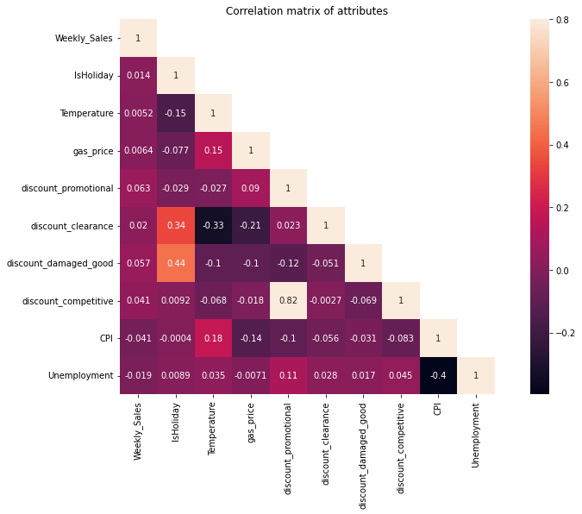

***Figure 1***: *The visualization of the correlation Matrix. The scale on the Right-hand side of the matrix provides a coefficient of correlation.*

***Inference***: *From the correlation graph, there is very strong correlation between discount_competetive and discount_promotional. One of the reasons behind that would be addition of new product in market, either by same company or by the competitor.*

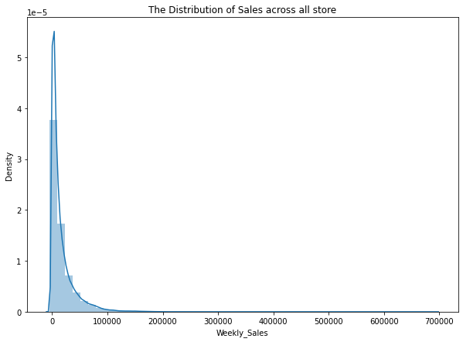

***Figure 2****:* *The distribution of Sales across all stores*

***Inference:*** *we can see highly skewed sales data*

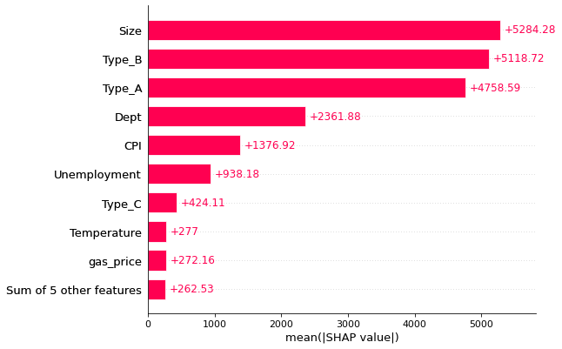

***Figure 3****:* *Feature importance using SHAP values*

***Inference:*** *Above graph shows important features in determining the sales. Size of store & Type of store are crucial to determine Weekly_sale.*

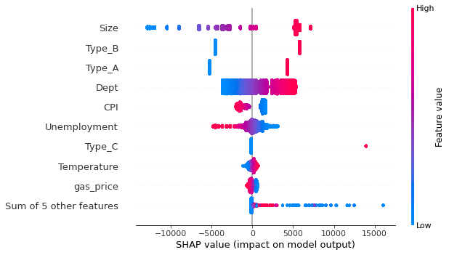

***Figure 4****:* *Beeswarm plot for SHAP values*

***Inference:*** *From Beeswarm plot, when size of store is bigger avg sales goes up. One of the reasons behind that will be availability & variety of products available in store. Smaller store will have space restriction to add more stuff in inventory thereby less foot traffic and sales. One of the important points to note here is only the biggest size causes more sales, medium and low store sizes show drop in average sale. Department being a categorical variable is still very important to determine sales. It is clear from the fact that one dept will perform better than other (Pharmacy, grocery), getting exact name of department will be useful to pinpoint Dept with highest sales. CPI & Unemployment shows negative trend with Sales. Increase in these two will cause sales to go down*

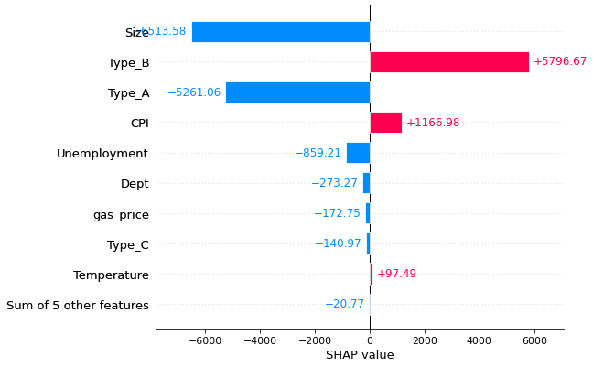

***Figure 5****:* *Waterfall SHAP values for first record*

***Inference:*** *This graph shows how smaller size, and less department are negatively impacting sales for one of the stores. CPI & Temperature have a positive impact on sales.*

#### 2.*2*.2 For the first 10 stores visualize the weekly and monthly sales patterns for the top 35% of the Department sales.

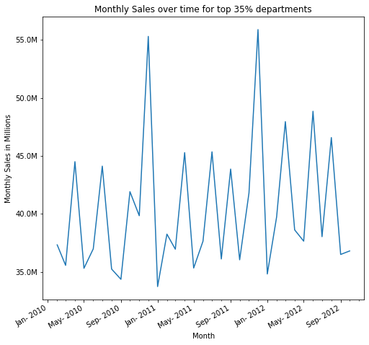

***Figure 6****:* *Graphical representation of the data that shows the Monthly sales (in Millions) over a period of time for top 35% departments*

***Inference:*** *It can be seen from the visualization of the data that the sales were lowest in the end of Jan considering holidays are already over*

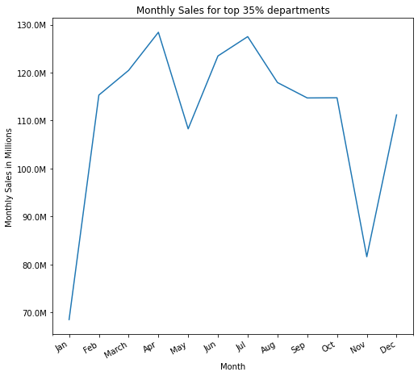

***Figure 7:*** *This graph represents the Month wise data of sales (in Millions) for top 35% departments*

***Inference:*** *From the visual output that can be seen above, we can infer that the sales were high in month of March because of spring break and low in Jan considering holidays already over*

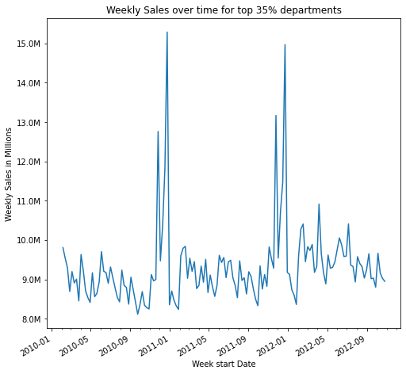

***Figure 8:*** *The graph above depicts the data of weekly sales (in Millions).*

***Inference:*** *It can be seen that there is a frequent fluctuation in the sales data, however it can also be seen that there are two major peaks in November because of Thanksgiving*

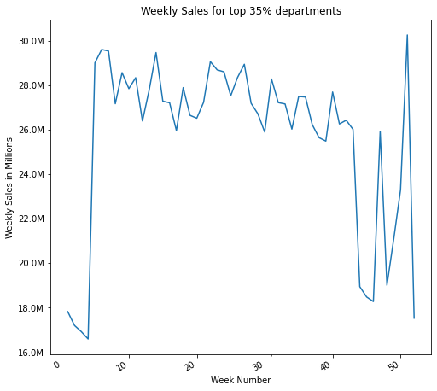

***Figure 9:*** *This data Visualization is a representation of the data of weekly sales in millions in correspondence with weekly number.*

***Inference:*** *We can see less sale during the start of the year*

#### 2.2.2.1 Identify the best department across the first ten stores

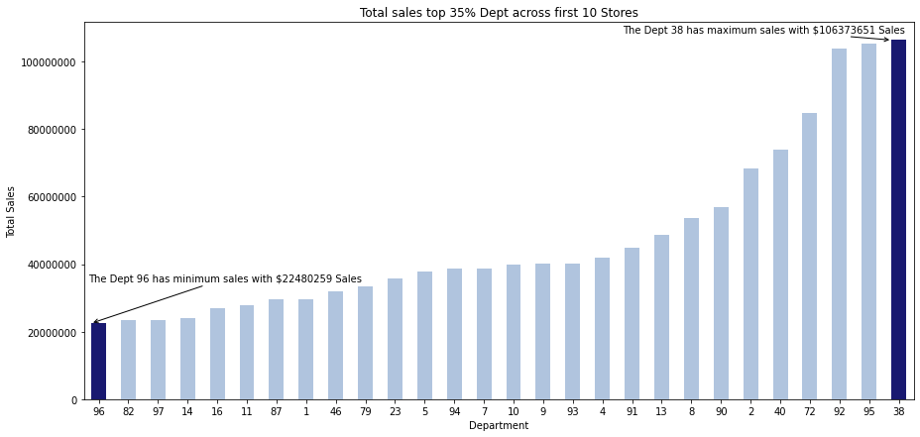

***Figure 10:*** *The above bar graph is a representation of sales patterns for top 35% of the department sales for first 10 Stores*

***Inference:*** *This graph indicates that the Dept 96 has very less sales with $22480259 whereas Dept 38 has maximum sales with $106373651.*

#### 2.*2*.3 Investigate the relationship between weekly sales over CPI and unemployment for the first 10 stores. You can explore the what-if scenarios while writing the report.

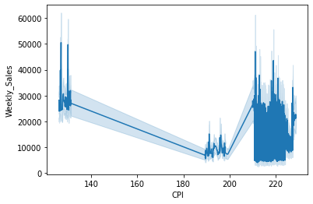

**Figure 11:** *the data above visually represents the relationship between the Weekly Sales and the CPI.*

***Inference:*** *Its can be seen that there Is a moderate level of concentration of weekly sales in the early points of the CPI. However, the concentration of points goes way higher between 200 and 220 and around 220 CPI. This same level also has the lowest level of the CPI. There is no evidence of correlation between CPI and Weekly_Sales. Lower CPI had higher weekly sales, however because of higher concentration of CPI around 220, its hard to draw conclusion for relationship.*

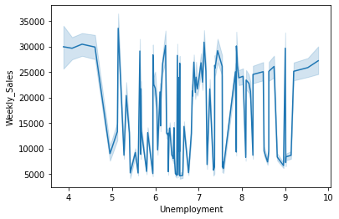

***Figure 12:*** *This is a graphical version of the data that portrays the data which shows us the relationship between Weekly_sales and Unemployment.*

***Inference:*** *This graph clearly shows that there is a very uneven relation between both the metrics. The graph starts off at 30000 weekly sales with around 4 unemployment. Contradictory to this, there were nearly 5000 sales with 6 to 7 unemployment factors.*

#### 2.*2*.4 Investigate the impact of various types of discounts, for example, discount promotional, discount clearance, discount damaged good, discount competitive and discount employee on the overall sales**.**

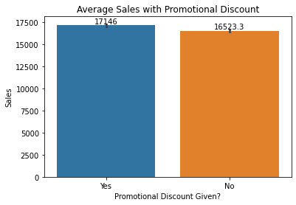

***Figure 13:*** *Sales Figures differences with or without Promotional Discount.*

***Inference:*** *This pictorial representation clearly shows that there are slightly more sales when Promotional Discount are taken into consideration.*

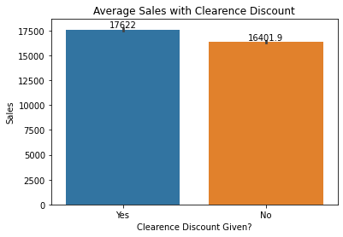

***Figure 14:*** *Total Sales with or without Clearance Discount.*

***Inference:***  *This is a clear demonstration of the statistics that shows that there are slightly more sales seen when the Clearance discount provided.*

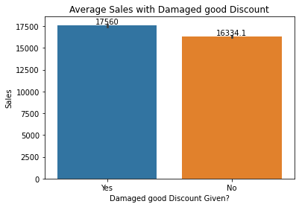

***Figure 15:*** *Total Sales when Damaged Good Discount given or not.*

***Inference:*** *It can be seen that the Damaged Good Discount is provided; the sales are slightly increased.*

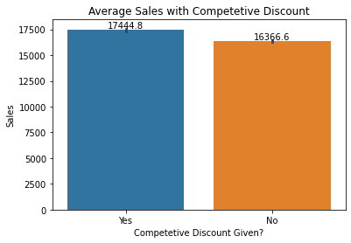

***Figure 16:*** *Total Sales when* *Competitive Discount is given or not.*

***Inference****: Another visual representation of the fact that when Competitive Discount are involved into the equation, the sales tend to go up.*

#### 2.2.4.1 Which types of discounts is helpful in increasing the sales? Consider top 30% of the best performing stores (sales per 1000 square feet).

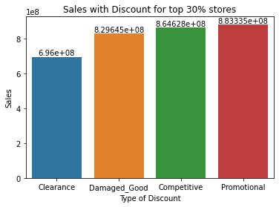

***Figure 17:***  *Graphical representation of the variation of the increment of the sales when different Discounts are taken into consideration for top 30% stores.*

***Inference:*** *In Comparison to all the* *discounts given for top 30 percent Stores,* *sales are seen to be maximum when Promotional Discounts are given.*

#### 2.2.4.2 Does the observed behavior hold true for all the stores? Consider bottom 30% of the least performing store (sales per 1000 square feet).

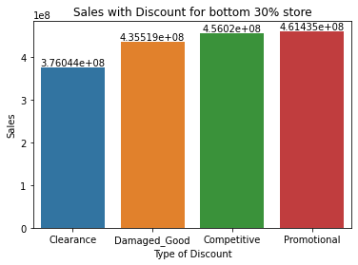

***Figure 18:*** *Graphical representation of the variation of the increment of the sales when different Discounts are taken into consideration for bottom 30% stores.*

***Inference:*** *Similar to the previous result, it can be seen here that Promotion Discounts perform way better in terms of sale in comparison to other sorts of discounts.*

#### **2.*2*.5** Identify the products which are highly impacted by external factors: “temperature”, “gas price”, and “holiday”. Is there any correlation between overall sales and holidays?

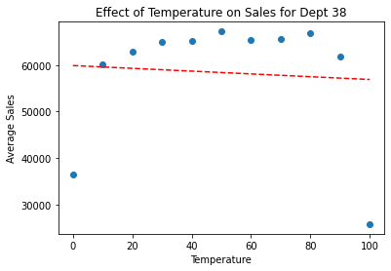

***Figure 19:*** *Graphical representation of effect of Temperature on Sales for Dept 38.*

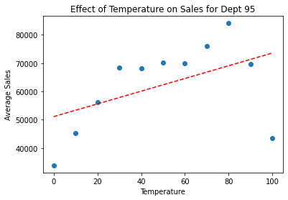

***Figure:*** *Graphical representation of effect of Temperature on Sales for Dept 95*

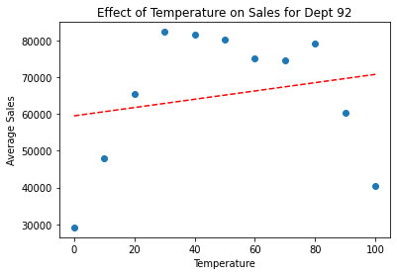

***Figure 20:*** *Graphical representation of effect of Temperature on Sales for Dept 92.*

***Inference from all the figures above considering the Temperature:*** *Relation between temperature and Sales is not linear. Low and high temperature sees lower sales, considering unwillingness of people to come out it too hot or too cold weather. Drawing the trendline shows how temperature is affecting top 3 Department. With temperature, sales for****Dept =38****goes down.*

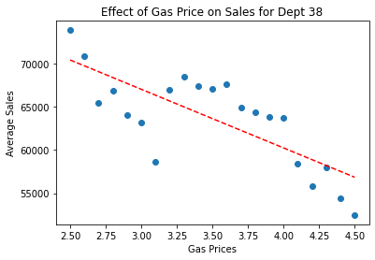

***Figure 21:*** *Graphical representation of effect of Gas Price on Sales for Dept 38*

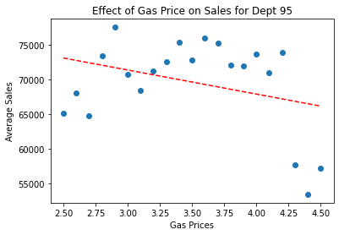

***Figure 22:*** *Graphical representation of effect of Gas Price on Sales for Dept 95*

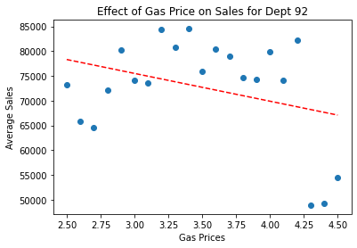

***Figure 23:*** *Graphical representation of effect of Gas Price on Sales for Dept 92*

***Inference from all the figures above considering the gas prices:*** *General trend for sales with gas prices is negative. With increase in gas prices, sales go down.****Department =38****is worst affected by gas prices. To further analyze it would be important to look at distance of store from nearby neighborhood.****Department=95****is least affected by gas prices.*

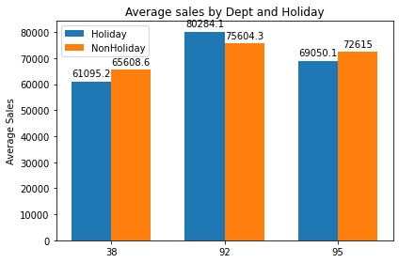

***Figure 24:*** *Graphical representation of the variation of the increment of the sales when different Discounts are taken into consideration for bottom 30% stores.*

***Inference: Department = 92****has higher average sales during Holidays. Other two departments have lower sales during holiday.*

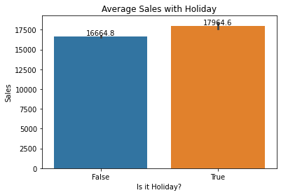

***Figure 25:*** *Graphical representation of Average Sales with Holiday.*

***Inference:*** *On average, sales during holidays is more than non-holiday seasons.*

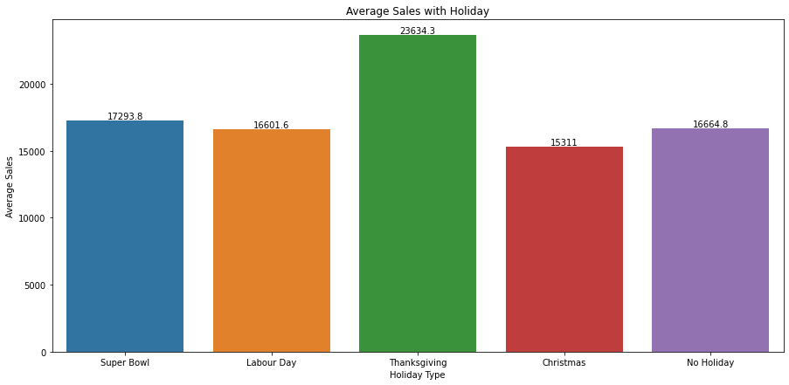

***Figure 26:*** *Graphical representation of Average Sales with Holiday*

***Inference:*** *With no surprise, Thanksgiving sales is highest. Customers tend to do most of the holiday shopping during that time. As a result, sales during Christmas is lower than usual. There can be multiple factors for this, one is pre shopping, other can be winter, people tend to not go out and celebrate with family*

### 2.3 Google Colab URL

*<*[*https://colab.research.google.com/drive/1paontoradBN5KuUtzlcBBbmquBtWpXcH?usp=sharing*](https://colab.research.google.com/drive/1paontoradBN5KuUtzlcBBbmquBtWpXcH?usp=sharing)*>*

## 3. Dataset 2

For dataset 2 we have deployed the tableau dashboard.

### 3.1 Problem Statement

1. Visualize the daily, monthly, and total sales in STATE1 and STATE2. Identity the department with the highest and lowest sales across all stores. You may make a comparison of “State” with “Item Categories”.
2. Determine the product sales and availability over time in each store, and average price on each category.
3. Visualize the monthly and total sales for each store and each category. Identify the most sold products in each state in each department.
4. Investigate the average sales of highly sold products for a given price of each month and on weekdays, and average sales on event types, for example, cultural, national, etc.

### 3.2 Final Dataset Visualization

We have analyzed dataset 2 in the following tableau dashboard (link to be displayed) and have described the key findings as follows.

#### 3.*2*.1 Selling price vs holidays based on categories

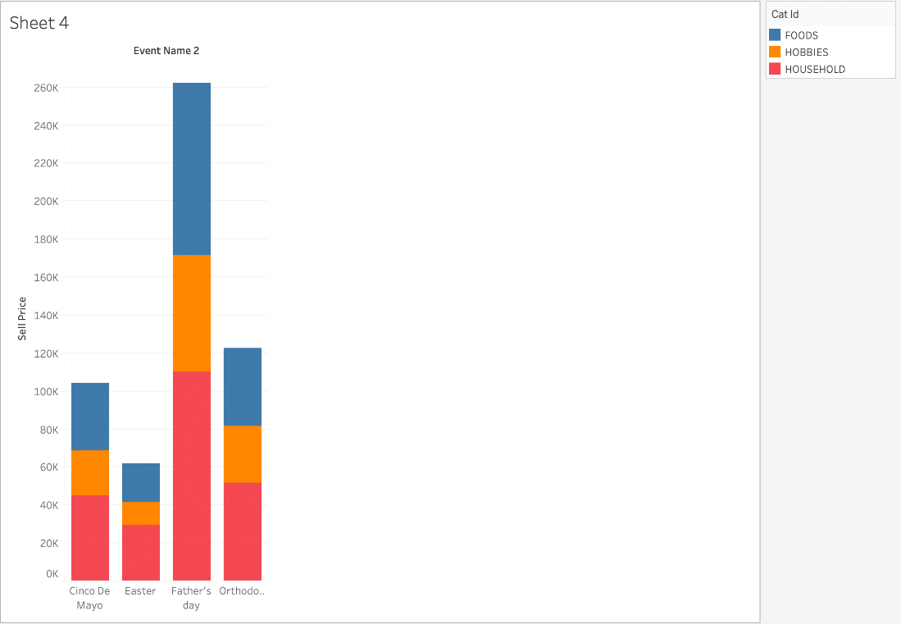

***Figure 27:*** *This data visualization represents the selling price on the 4 holidays for the categories of Food, Hobbies and Households.*

***Inference****: For any category, Easter has the lowest selling price.*

#### 3.*2*.2 Selling price based on holidays across three categories

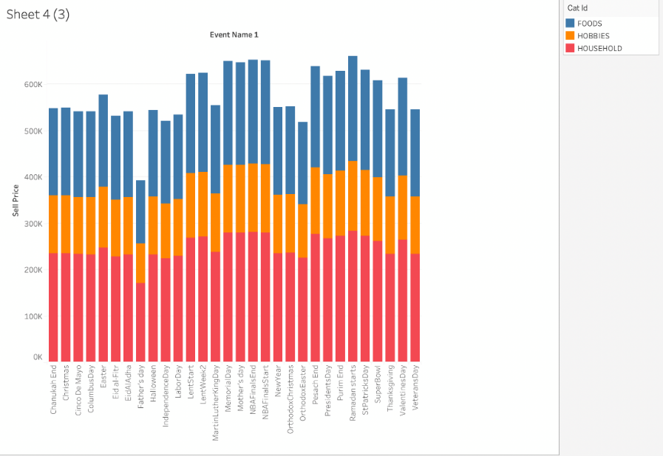

***Figure 28:*** *This is a much more detailed visualization of the graphs that represent the selling price of the 3 categories across the multiple holidays (more than 4)*

***Inference****: It can be seen that Father's Day has the lowest whereas Ramadan Starts Day has the highest selling price*

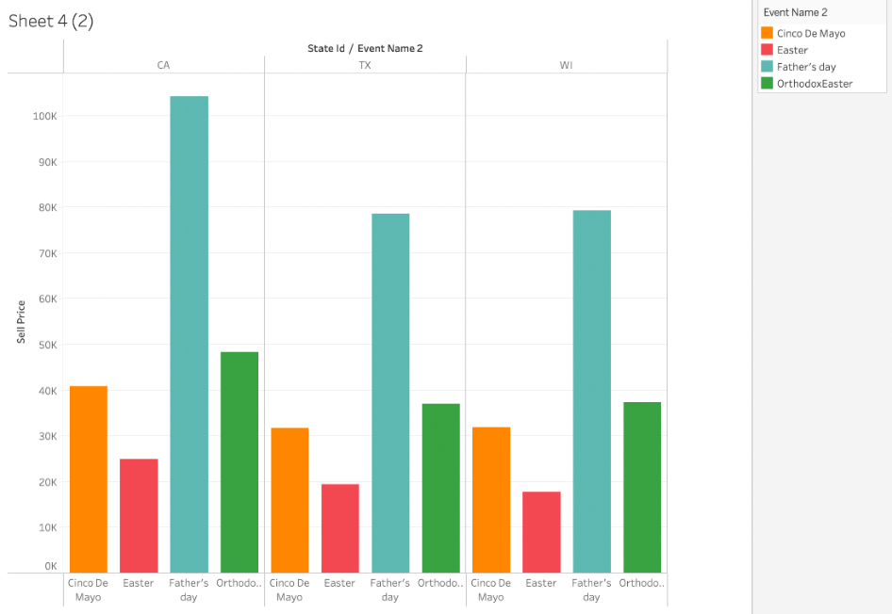

***Figure 29:*** *This Graph is a visual representation of the data that shows the selling price on multiple days (in this case 4), in 3 states (California, Texas, Wisconsin)*

***Inference****: California has the highest selling price on Father's Day. Overall easter has lowest number of selling price in all the states.*

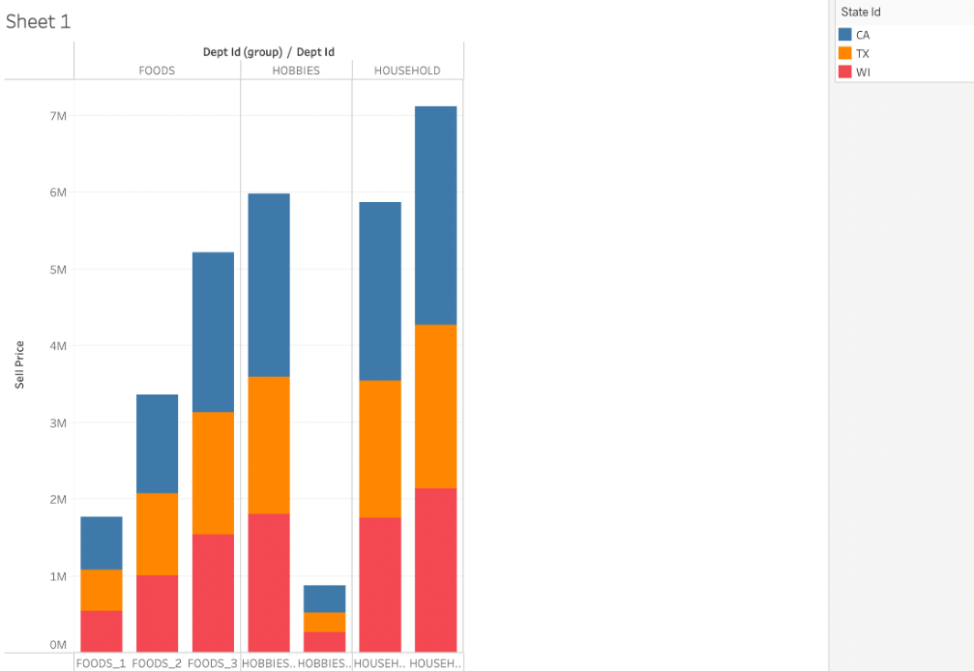

***Figure 30:*** *This visual representation of the data depicts the multiple items in the 3 categories (Food, Hobbies, Households) in 3 states (California, Texas, Wisconsin)*

***Inference****: 2nd micro category of Hobbies has the lowest selling price across all the states however 2nd micro category of the Household has the highest selling price across all the states.*

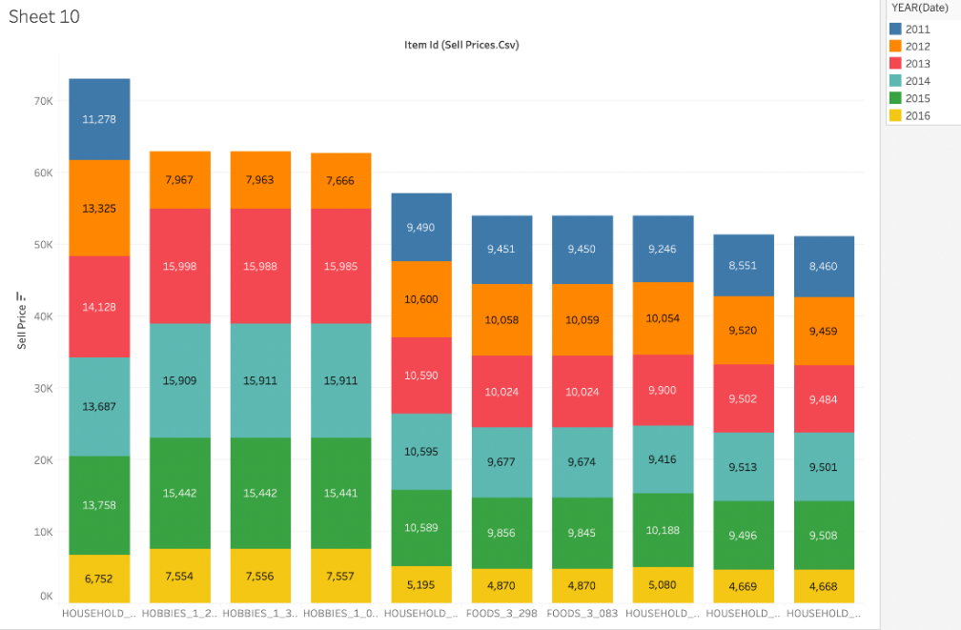

***Figure 31:*** *This graph represents the data that shows the selling price of the multiple categories (Household, Hobbies, Foods) that are further divided into micro categories and shows the percentage ratio of the selling price in the multiple years (from 2011 to 2016).*

***Inference****: The graph clearly depicts that 1st micro category of Households has the most significant selling price from 2011 to 2016. However, in the last micro category of Households, the selling price spanning 6 years, from 2011 to 2016, is the lowest.*

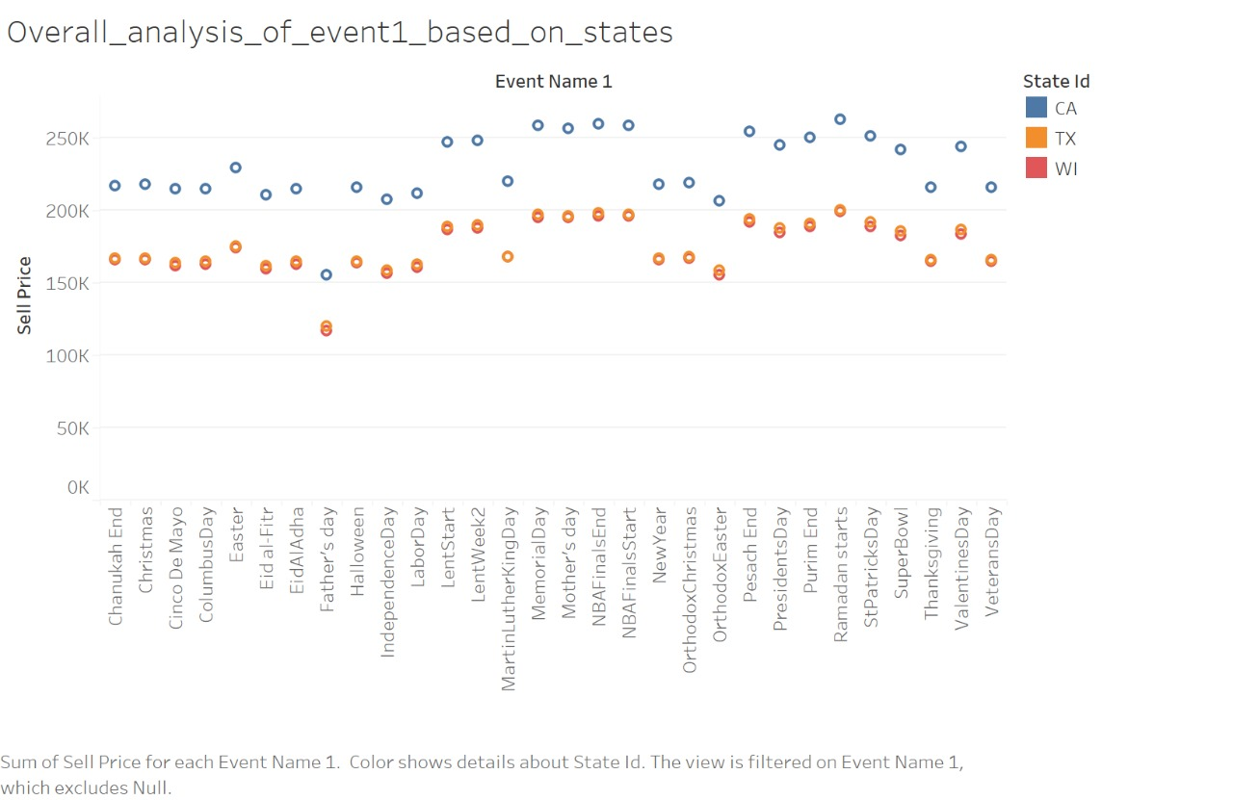

***Figure 32:*** *The plotted graph above displays the sum of the Sell Price for multiple events in Event Name 1.*

***Inference:*** *It is clear from the graph that the selling price for each day in the Event Name 1 in 3 States (California, Texas, and Wisconsin) are almost always above 150K with the selling price for the state of California almost always above 200K. It can also be seen that. The selling price for Texas and Wisconsin are nearly the same.*

# B) Sprint 2

## 4. Dataset 1

For dataset 1, we have created the Colab Notebook for data visualization.

### 4.1 Problem Statement

#### *4*.1.1 Analyze the dataset_01

For the first part, we designed a prediction model to forecast the weekly sales across first ten stores and used the same model to make predictions for store_11_35. We began with Linear Regression Model. We performed the analysis with other models like Ridge and Ada Booster.

For the second part, we designed multiclass classfication to predict the store type using features mentioned. Classification algorithms used are 3 ensemble methods, RNN and CNN.

### 4.2 Final Dataset Visualization:

#### *4.*2.1 Machine Learning Models

#### Feature Engineering

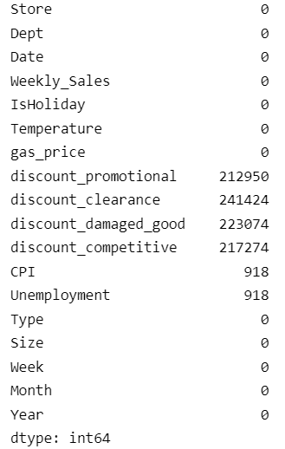

***Figure 33****: multiple coloumns and their values against them*

***Inference****: It is visually clear that the coloumns containing “discounts” have the highest values compared to all other coloumns.*

Discount columns have maximum null values. We have checked previously from correlation plot that, discount_promotional & discount_competitive are highly correlated. We will drop one of these to avoid multi-collinearity. Secondly, we will add columns which gives us insights if discount was given or not. Then, we will replace null values of these discount columns with zero. Missing values in CPI, Unployement are very less, it would be best to drop them.



***Figure 34:*** *Effect of Temperature on Sales for Dept 92*

***Inference:*** *The graph of Weekly sales vs temperature is not linear. It seems like the temperature increases weekly sales increases but as diminishing effect. So, after certain temperature sales go down with an increase in temperature. The reason behind that could be people like to shop when it’s nice weather and prefer not to go out in extreme heat or cold. We will add a Squared term for temperature to capture the diminishing return.*

*Data is preprocessed & adding a few more features, we will remove Date & Store ID from data frame as they will not add any value for linear regression.*

#### Regression

##### Linear Regression Without PCA

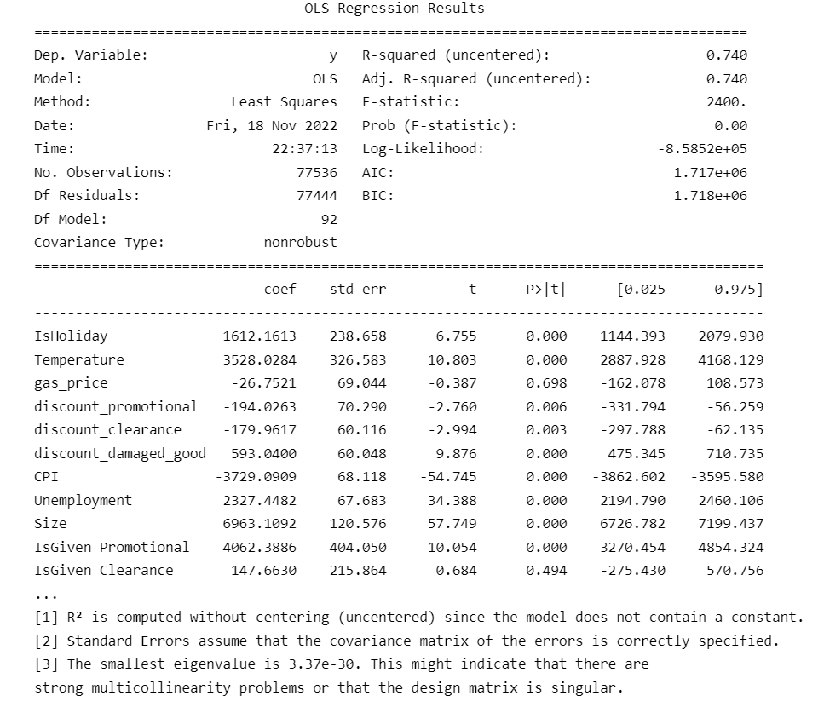

***Figure 35****: Linear Regression Results*

***Inference****: It can be seen that R2 for the model turns out to be 0.74. Now because the model is performing in moderate conditions, it will predict the sales. It can also be seen that “Dept” has impacted the sales.*

*From above table the R2 for model is 0.74. Model is performing well to predict the sales. Dept has high impact on sales as p-value for almost all Dept is significant (p < 0.05). As expected, Temperature square has negative coefficient. Features that do not have impact on Weekly sales ( p-value > 0.05) :  
gas_price  
IsGiven_Clearance  
Dept_19  
Dept_27  
Dept_28  
Dept_36  
Dept_19  
Dept_39  
Dept_51  
Dept_60  
Dept_77  
Type_c*

***Insights:*** *Customer's shopping behavior doesn't change with increase in gas prices. Customers do care about if promotional offers & discounts on damaged goods. Also amount of offer given improves sales. It doesn't matter if discount is given on clearance items but if the discount given is more than customers prefer to buy that. Most of the departments are different than Dept_1. But few departments don’t change behavior of purchase for customers. Getting exact names of department can improve insights.*

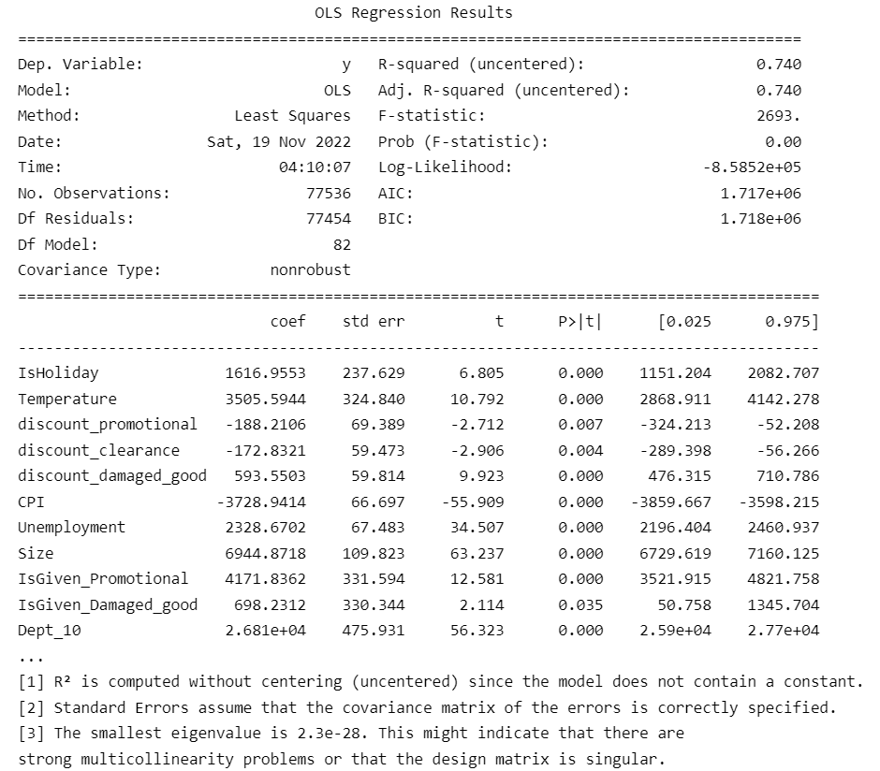

***Figure 36****: Linear Regression Results*

***Inference****: Removing those features didn’t change R2 for the model.*

##### Linear Regression With PCA

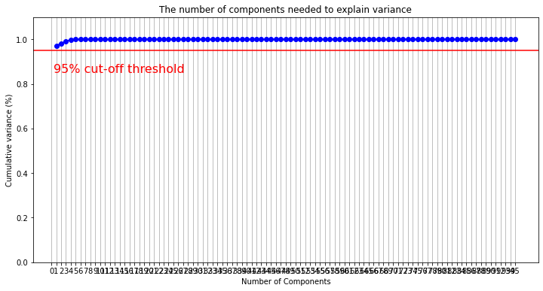 ***Figure 37****: The number of components needed to explain variance*

***Inference:*** *Including 8 features can explain varince of more than 95% from prediction label.*

##### ARIMA

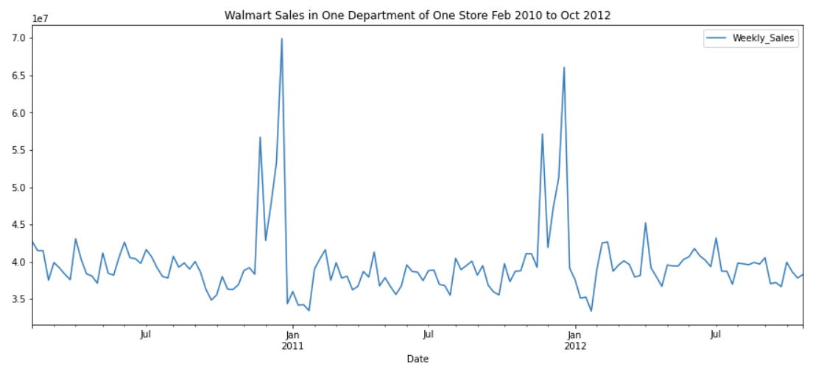

***Figure 38****: Visual data of the sales in one department of one store from Feb 2010 to Oct 2012*

***Inference:*** *It is evident from the graph above that there are 4 general spikes in the graph. They are around November, December, February, and April.*

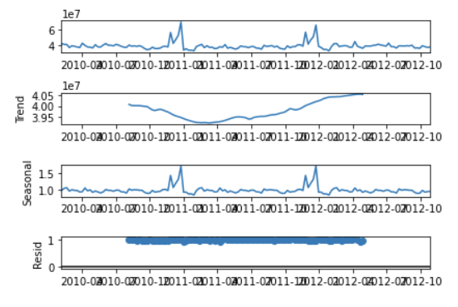

***Figure 39****: Graphical presentation of the change in the values of “trend, seasonal, residual” over a duration of multiple months for almost 2 years.*

***Inference:*** *from the image above, we can see that plot for “trend” falls for a couple of months but then gradually grown over several month ahead. As for “residual” it always stays at 1 over the entire duration of months.*

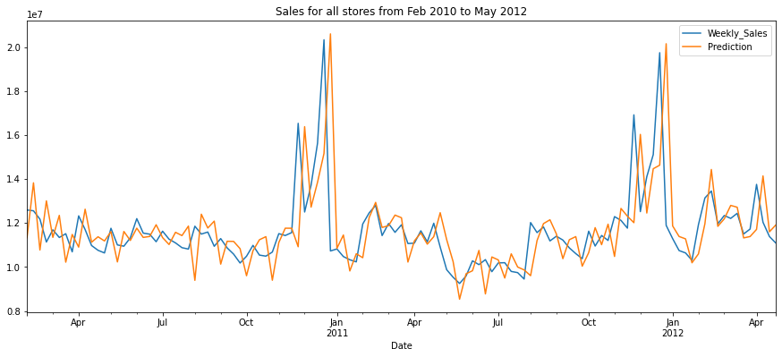

***Figure 40:*** *Plotted graph of weekly sales and prediction sales over the months from Feb 2010 to May 2012*

***Inference:*** *The predication follows the trend for Weekly_Sales. Model is performing good for future sale prediction*

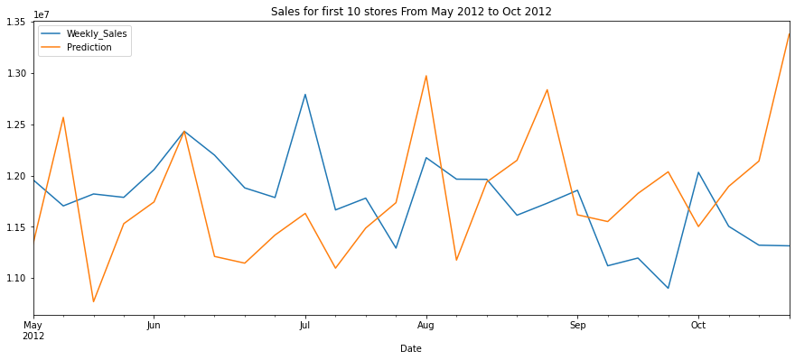 ***Figure 41:*** *Sales for first 10 stores From May 2012 to Oct 2012*

***Inference:*** *These are the predictions for test dataset*

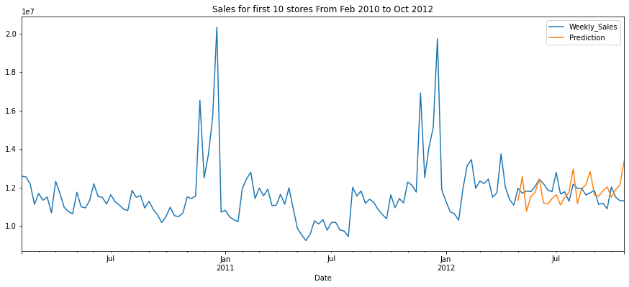

***Figure 42:*** *Sales**for first 10 stores from feb 2010 to oct 2012*

***Inference:*** *These are the predictions for whole dataset*

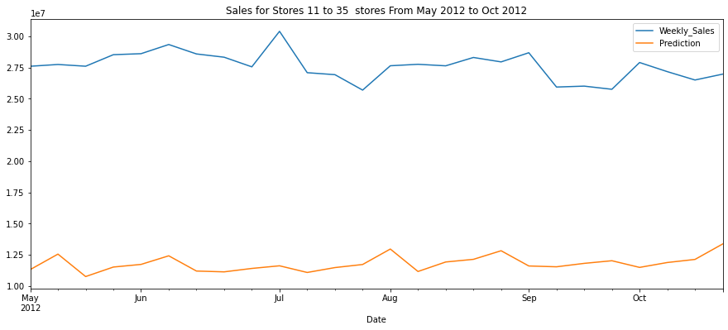

***Figure 43:*** *Sales**for stores 11 to 35 from May 2010 to Oct 2012*

***Inference:*** *Predicting the Weekly Sales for stores using ARIMA Model trained on first 10 stores*

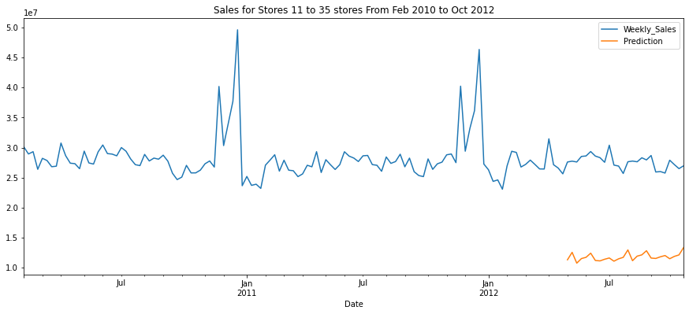 ***Figure 44:*** *Sales**for stores 11 to 35 from May 2010 to Oct 2012*

***Inference:*** *These are the predictions for whole dataset*

##### Regression Result

Performance of linear regression is better because properties of the linear-regression models are well understood and can be trained quickly.

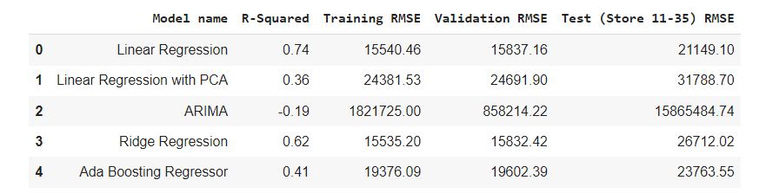

***Figure 45:*** *Regression results for all the models*

***Inference:*** *We can see that linear regression performance is better as compared to other models. Even after performing hyper-parameter tuning on ARIMA, Ridge and Ada boosting, the accurancy is low. For ARIMA, prediction is based on sum of sales across all departments of first 10 stores. The performance of ARIMA is better to predict future sales of those 10 stores but not for stores 11-35.*

#### Ensemble Models

##### Random Forest Classifier

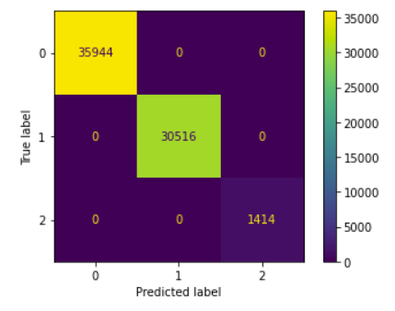

***Figure 46:*** *Confusion Matrix for the Random Forest Classifier*

***Inference:***  *Accuracy is 100%*

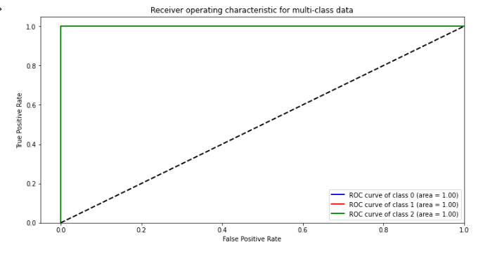

***Figure 47:*** *ROC Curve for the Random Forest Classifier*

##### XGBoost

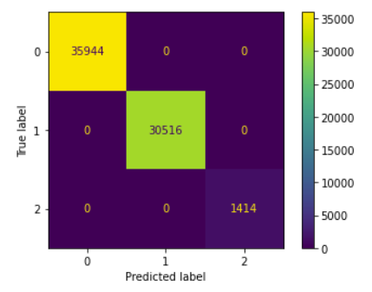

***Figure 48:*** *Confusion Matrix for the XGBoost*

***Inference:*** *Accuracy is 100%*

**

***Figure 49:*** *ROC Curve for the XGBoost*

##### LightGBM

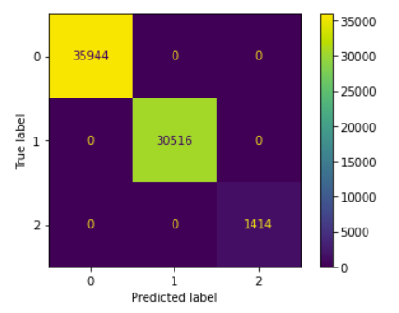

***Figure 50:*** *Confusion Matrix for the LightGBM*

***Inference:*** *Accuracy is 100%*

**

***Figure 51:*** *ROC Curve for the LightGBM*

##### Recurrent neural network (RNN)

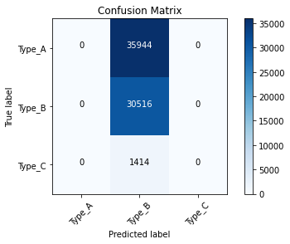

***Figure 52 :*** *Confusion Matrix for the RNN*

***Inference:*** *Accuracy is 44%*

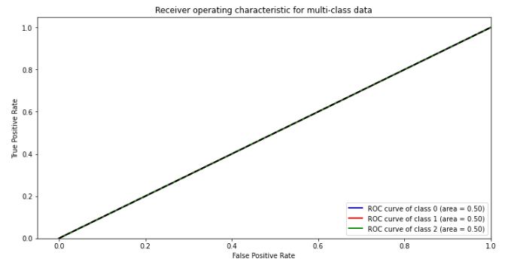

***Figure 53 :*** *ROC Curve for the RNN*

##### Convolutional Neural Networks (CNN)

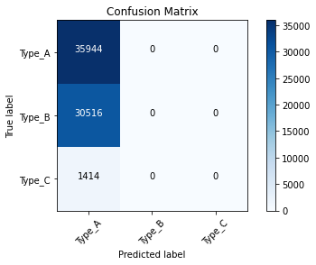

***Figure 54:*** *Confusion Matrix for the CNN*

***Inference:*** *Accuracy is 52.45 %*

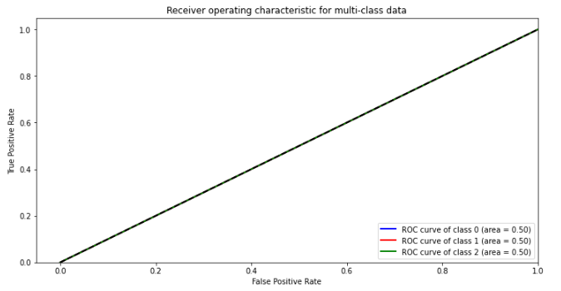

***Figure 55:*** *ROC Curve for the CNN*

##### Classification Result

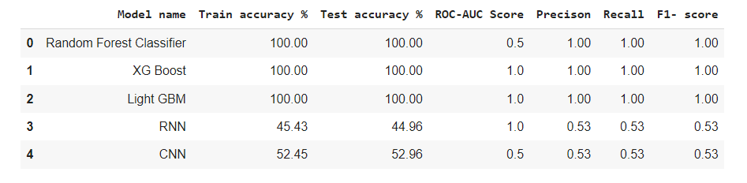

Ensemble models performs better as compared to neural network model as neural network models are non-linear and have a high variance.

### 4.4 Colab Link

*<*[*https://colab.research.google.com/drive/1paontoradBN5KuUtzlcBBbmquBtWpXcH?usp=sharing*](https://colab.research.google.com/drive/1paontoradBN5KuUtzlcBBbmquBtWpXcH?usp=sharing)*>*

## 5. Dataset 2

For dataset 2 we have deployed the tableau dashboard.

### 5.1 Problem Statement

1. Visualize the daily, monthly, and total sales in STATE1 and STATE2. Identity the department with the highest and lowest sales across all stores. You may make a comparison of “State” with “Item Categories”.
2. Determine the product sales and availability over time in each store, and average price on each category.
3. Visualize the monthly and total sales for each store and each category. Identify the most sold products in each state in each department.
4. Investigate the average sales of highly sold products for a given price of each month and on weekdays, and average sales on event types, for example, cultural, national, etc.

### 5.2 Final Dataset Visualization

#### *5.2*.1 Exploratory Data Analysis

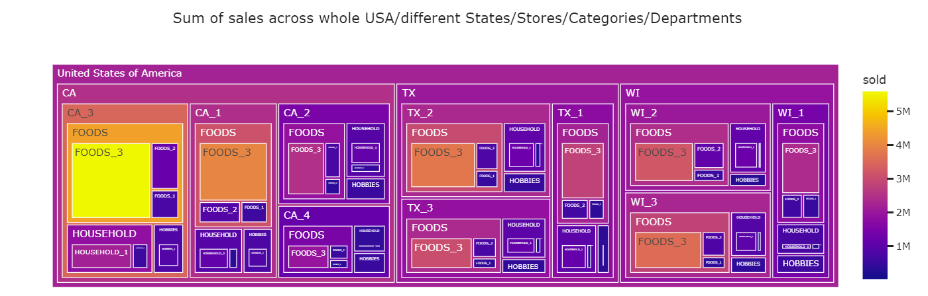

***Figure 56:*** *Block diagram of the sum of sales across whole in USA in different states, stores, categories, departments*

***Inference:***  *It can be inferred from the diagram that foods_3 across ca_3, ca_1, tx_2, tx_1, wi_3, tx_3 stores has the highest sales in the us whereas other sales in other departments have the lowest sales in.*

#### *5.2*.2 Exploratory Data Analysis to prove that Seasonality Exists

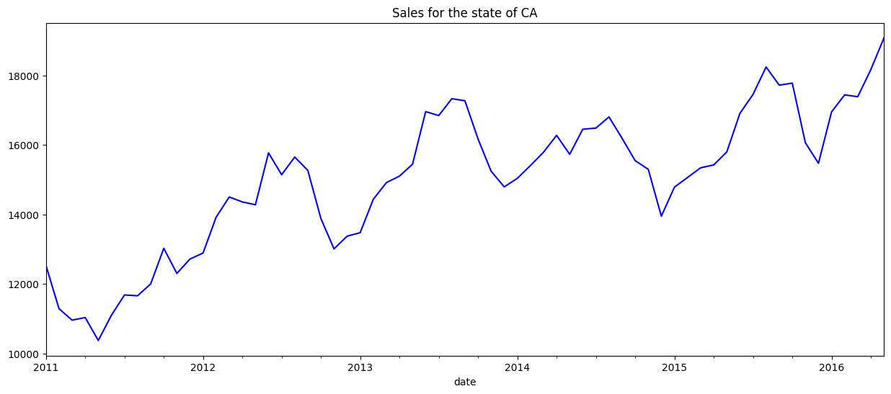

***Figure 57:*** *Sales**in the state of California over a period of over 6 yrs.*

***Inference:***  *It can be interpreted that there is a general growth in sales from 2011 to 2016 with slight occasional drops between 2012 and 2015.*

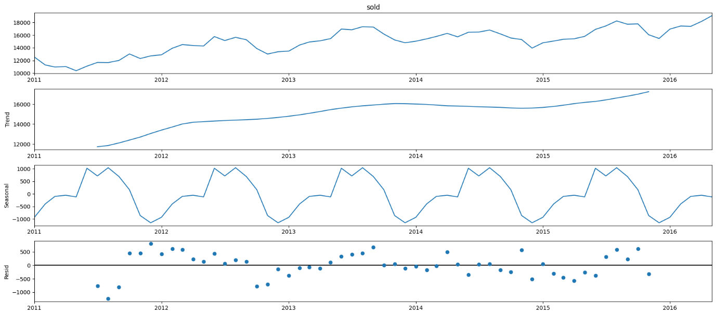

***Figure 58:*** *multi graph image**with graphs of Trend, Seasonal and Resid.*

***Inference:*** *There is a trend of general growth in the graph of Trend. In the seasonal graph there is a repetitive fluctuation over the course of 6 years. As for Resid the lowest plot goes below -1000 and the highest plot goes above 500 multiple times over the period of 6 years.*

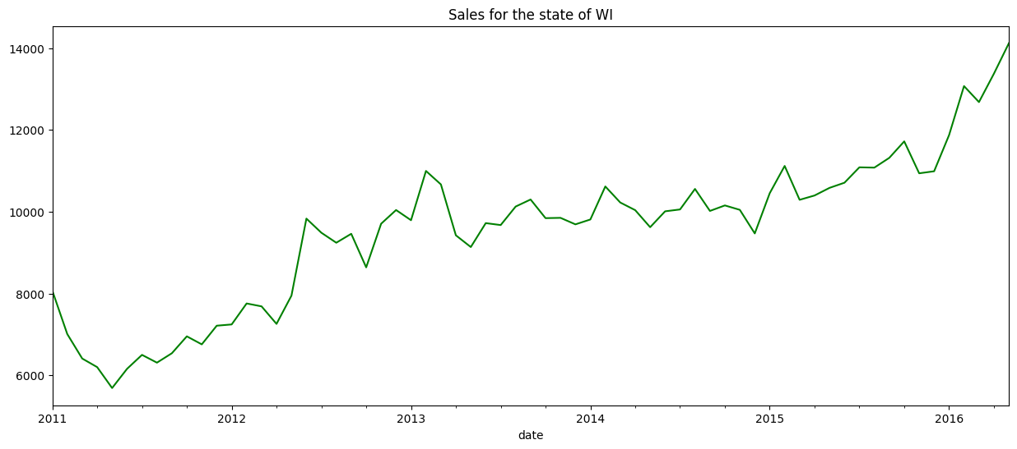

***Figure 59:*** *Sales**in the state of Wisconsin over a period of over 6 yrs*

***Inference:*** *It can be interpreted that there is a general growth in sales from 2011 to 2016 with slight occasional drops.*

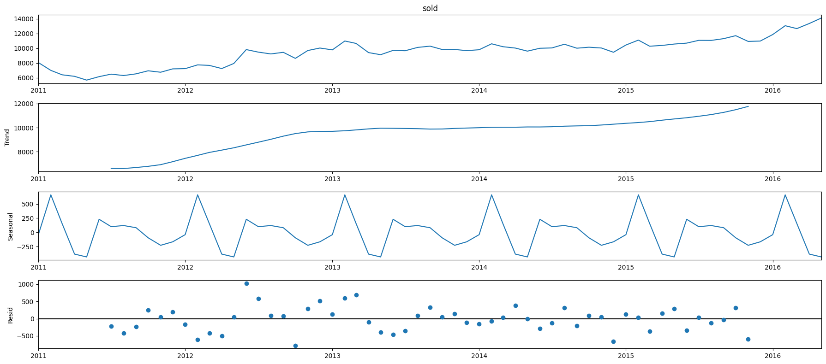

***Figure 60:*** *multi graph image**with graphs of Trend, Seasonal and Resid.*

***Inference:*** *There is a trend of general growth in the graph of Trend. In the seasonal graph there is a repetitive fluctuation over the course of 6 years. As for Resid the lowest plot goes below -500 and the highest plot goes to 1000 in the period of 6 years*

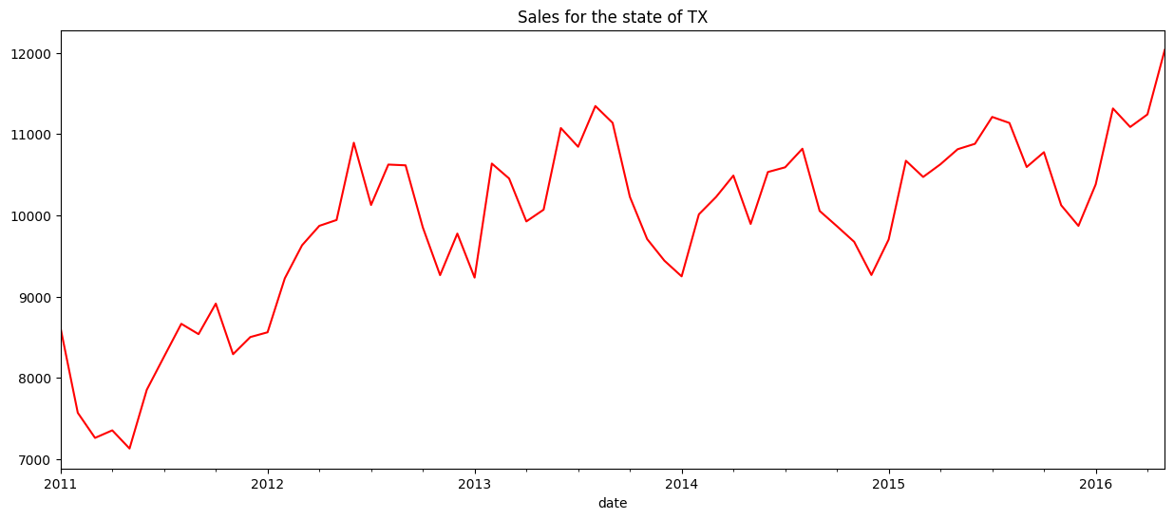

***Figure 61:*** *Sales**in the state of Texas over a period of over 6 yrs*

***Inference:*** *It can be interpreted that there is a general growth in sales from 2011 to 2016 with slight occasional drops in 2012 and 2015.*

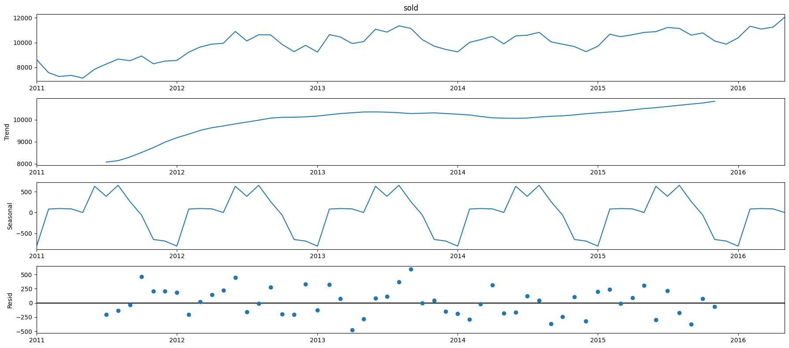

***Figure 62:*** *multi graph image**with graphs of Trend, Seasonal and Resid.*

***Inference:*** *There is a trend of general growth in the graph of Trend. In the seasonal graph there is a repetitive fluctuation over the course of 6 years. As for Resid the lowest plot goes to -500 and the highest plot goes above 500 in the period of 6 years*

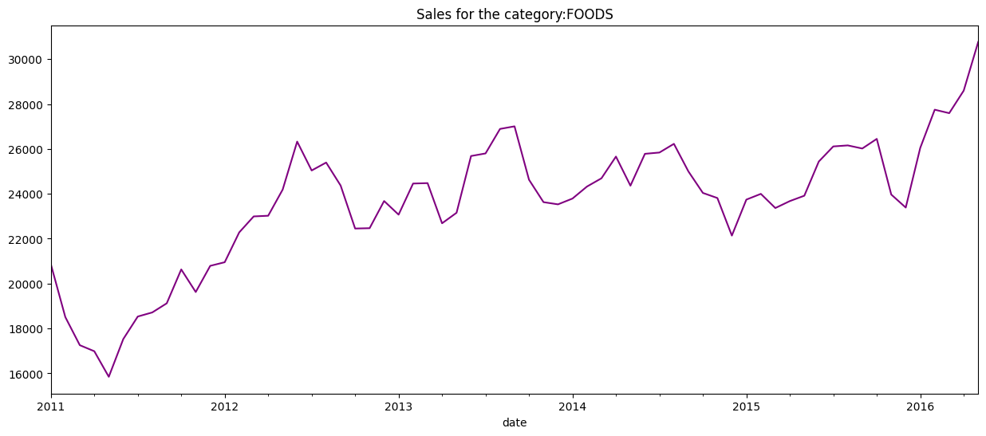

***Figure 63:*** *Sales**in the category of Foods over a period of over 6 yrs*

***Inference:*** *It can be interpreted that there is a general growth in sales from 2011 to 2016 with slight occasional drops.*

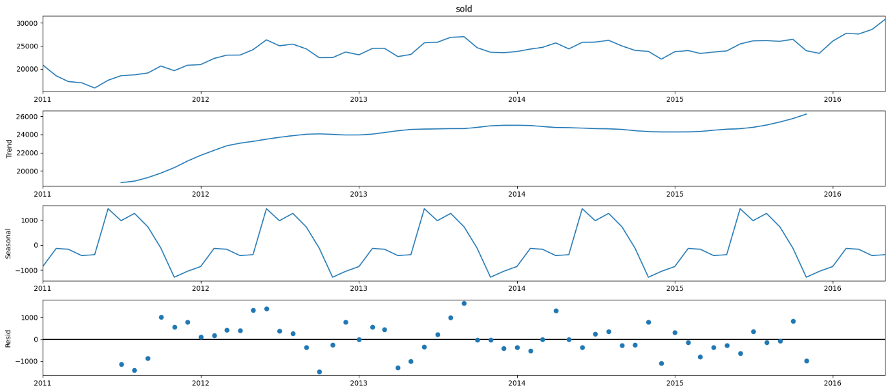

***Figure 64:*** *multi graph image**with graphs of Trend, Seasonal and Residual.*

***Inference:*** *There is a trend of general growth in the graph of Trend. In the seasonal graph there is a repetitive fluctuation over the course of 6 years. As for Residual the lowest plot goes below -1000 and the highest plot goes above 1000 over the period of 6 years*

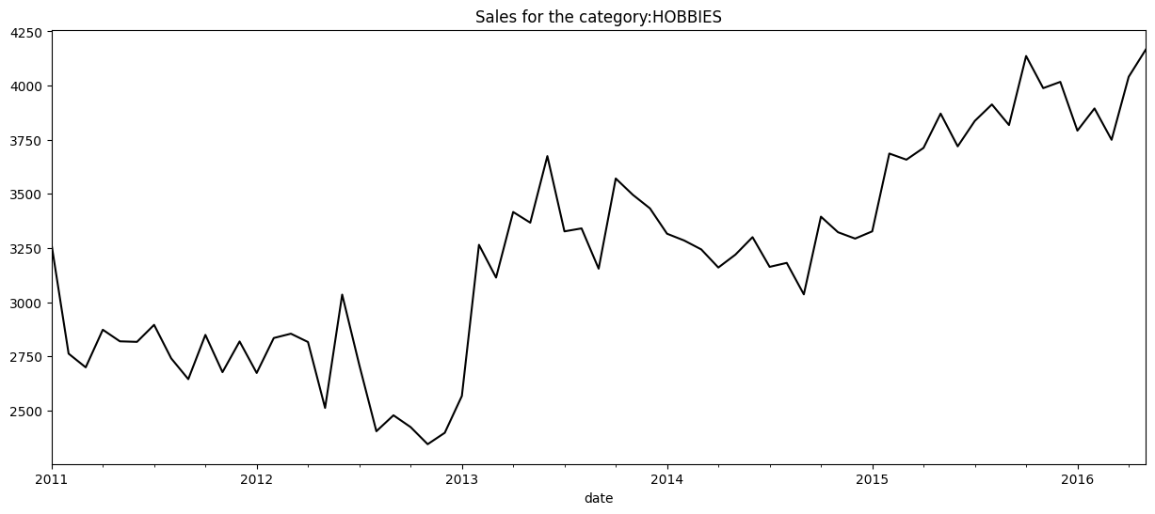

***Figure 65:*** *Sales**in the category of Hobbies over a period of over 6 yrs*

***Inference:*** *It can be interpreted that there is a general growth in sales from 2011 to 2016 with one major drop between 2012 and 2015.*

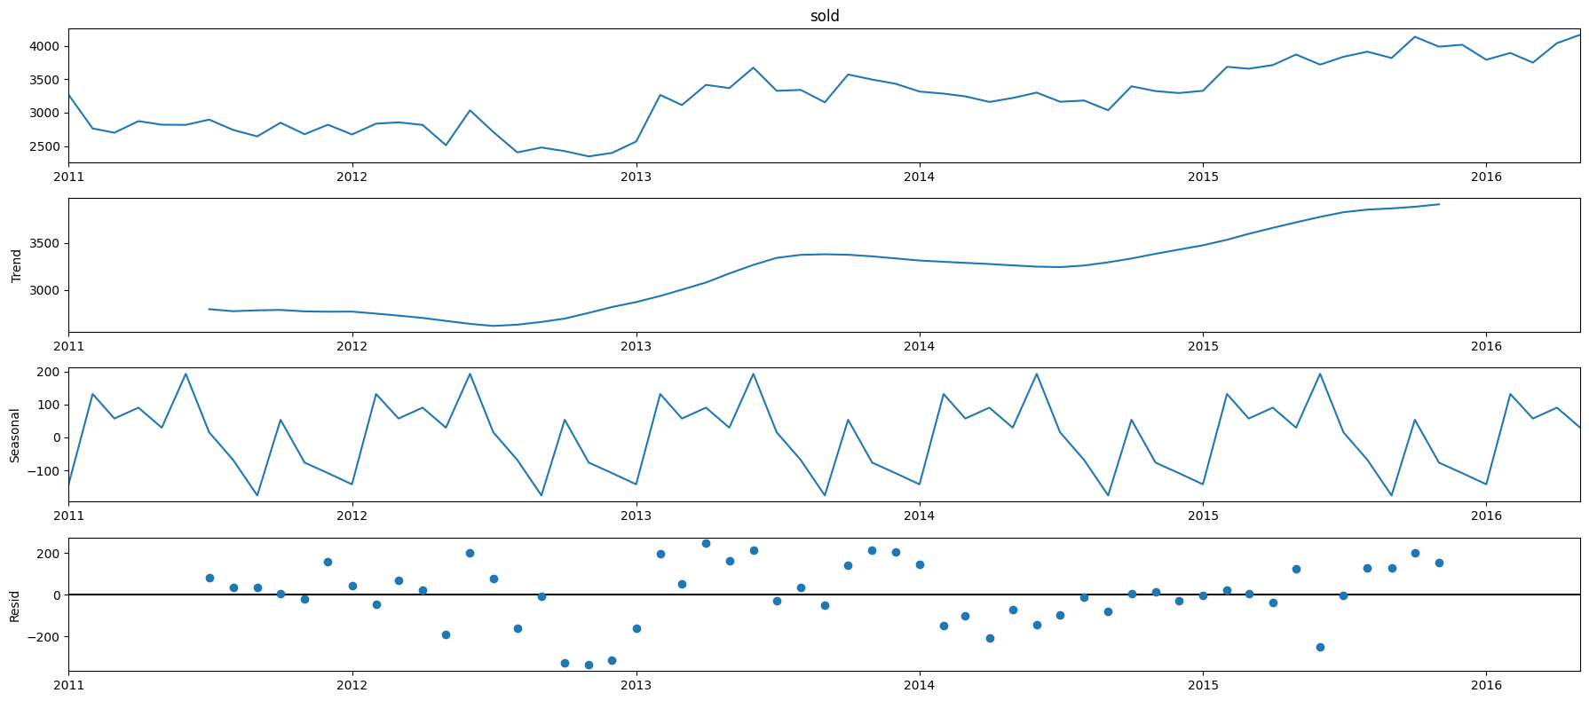

***Figure 66:*** *multi graph image**with graphs of Trend, Seasonal and Resid.*

***Inference:*** *There is a trend of general growth in the graph of Trend. In the seasonal graph there is a repetitive fluctuation over the course of 6 years. As for Resid the lowest plot goes below -200 and the highest plot goes above 200 over the period of 6 years*

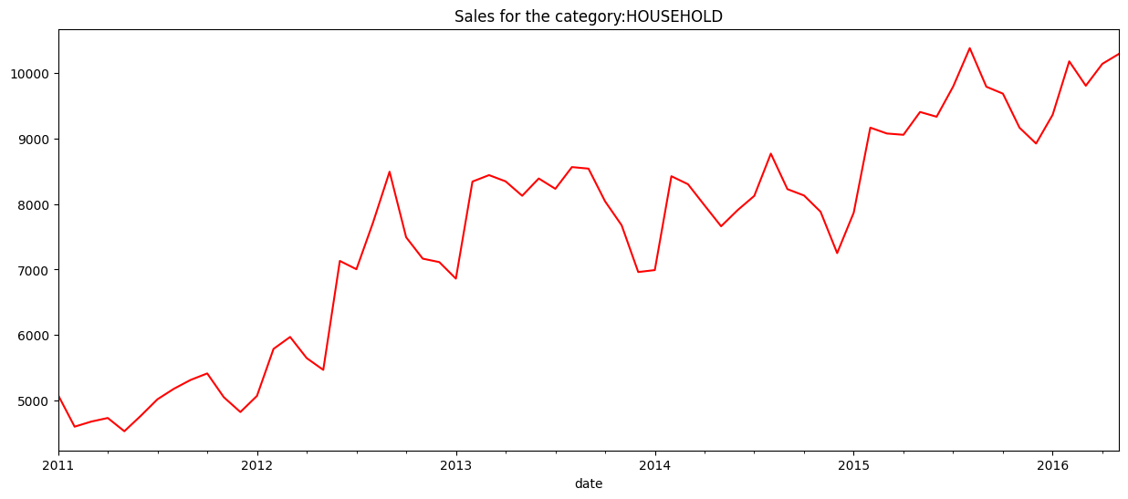

***Figure 67:*** *Sales**in the category of Household over a period of over 6 yrs*

***Inference:*** *It can be interpreted that there is a general growth in sales from 2011 to 2016 with some drops between 2012 and 2015.*

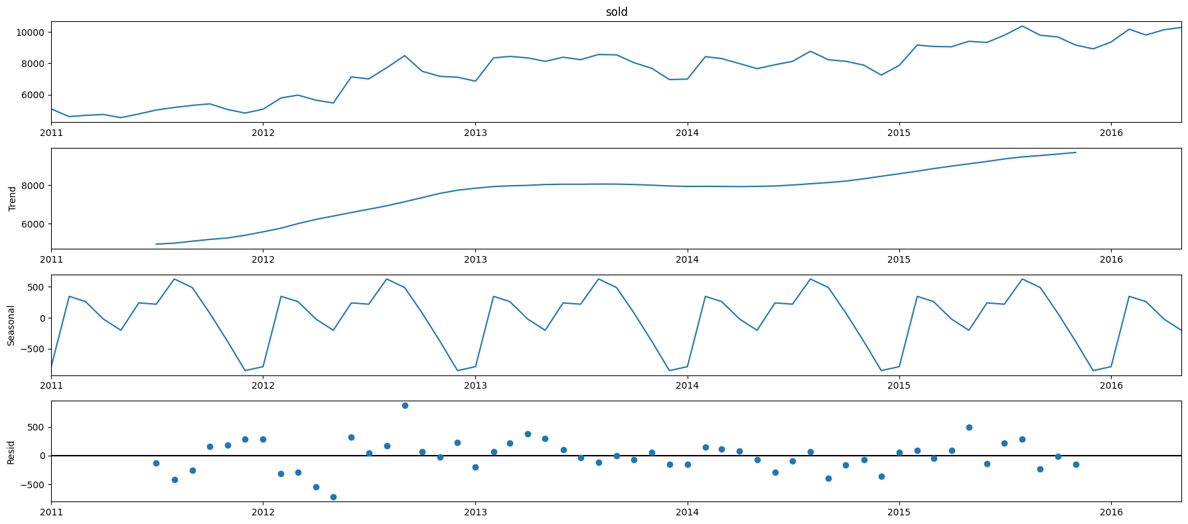

***Figure 68:*** *multi graph image**with graphs of Trend, Seasonal and Resid.*

***Inference:*** *There is a trend of general growth in the graph of Trend. In the seasonal graph there is a repetitive fluctuation over the course of 6 years. As for Resid the lowest plot goes below -500 and the highest plot goes above 500 over the period of 6 years*

#### *5.2*.3 Sales_function by store

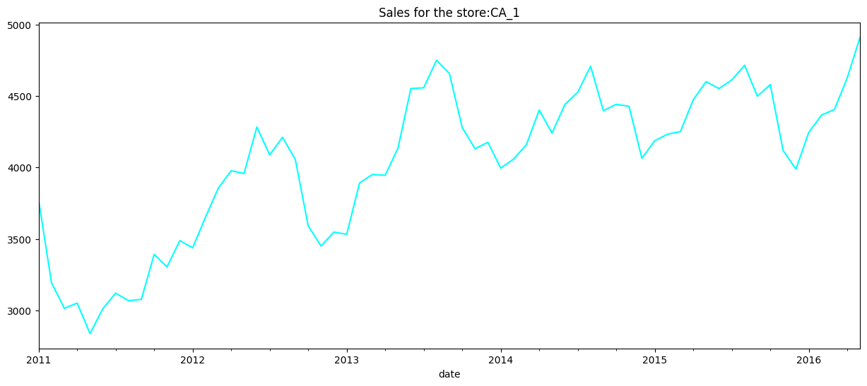

***Figure 69:*** *Sales**in the store CA_1 over a period of over 6 yrs*

***Inference:*** *It can be interpreted that there is a general growth in sales from 2011 to 2016 with two major drops between 2012 and 2014.*

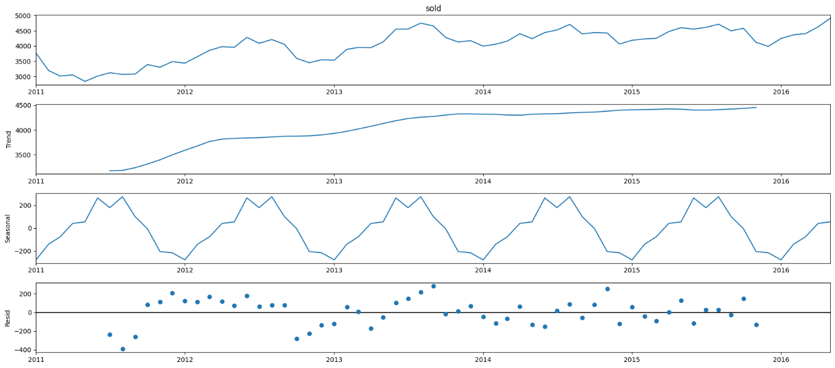

***Figure 70:*** *multi graph image**with graphs of Trend, Seasonal and Resid.*

***Inference:*** *There is a trend of general growth in the graph of Trend. In the seasonal graph there is a repetitive fluctuation over the course of 6 years. As for Resid the lowest plot goes below -400 and the highest plot goes above 200 over the period of 6 years*

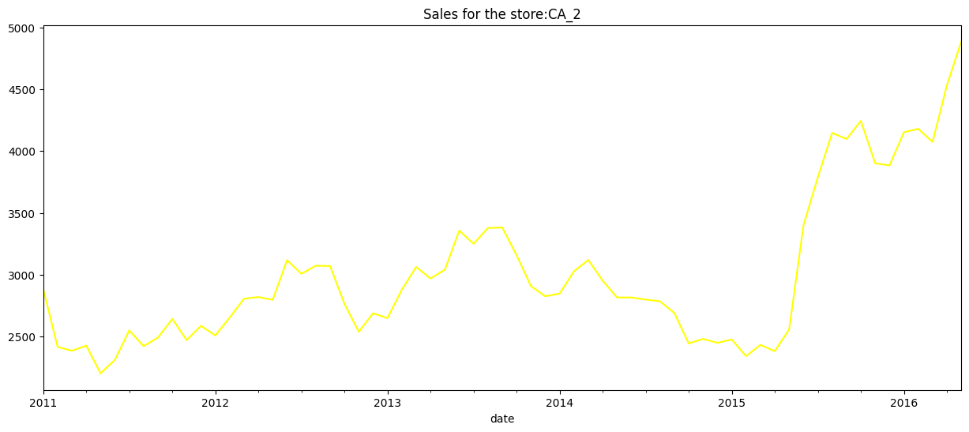

***Figure 71:*** *Sales**in the store CA_2 over a period of over 6 yrs*

***Inference:*** *It can be interpreted that there is a growth in sales from 2011 to 2016 with two major drops between 2012 and 2013 and 2015 and 2016.*

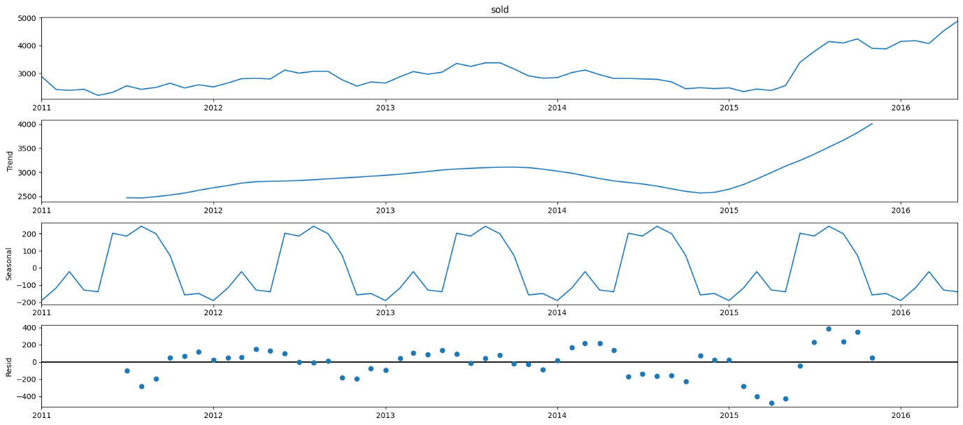

***Figure 72:*** *multi graph image**with graphs of Trend, Seasonal and Resid.*

***Inference:*** *There is a trend of growth in the graph of Trend in the end before plateauing between 2012 and 2015. In the seasonal graph there is a repetitive fluctuation over the course of 6 years. As for Resid the lowest plot goes below -400 and the highest plot goes above 400 over the period of 6 years*

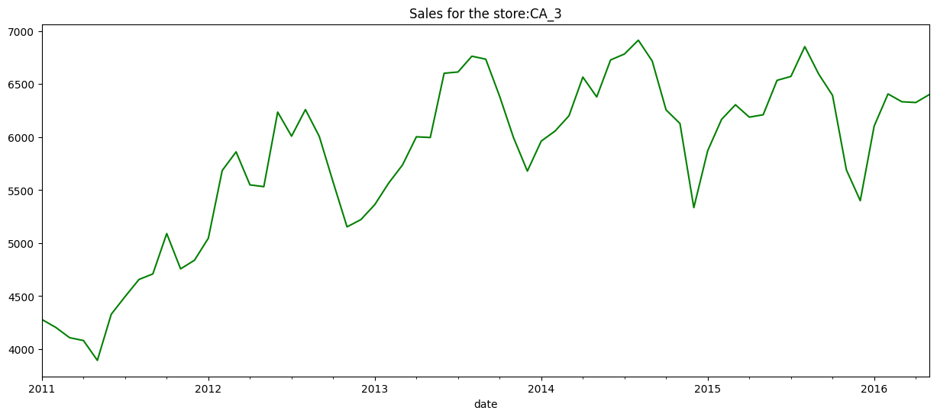

***Figure 73:*** *Sales**in the store CA_3 over a period of over 6 yrs*

***Inference:*** *It can be interpreted that there is a growth in sales from 2011 to 2016 with major drops between 2012 and 2016,*

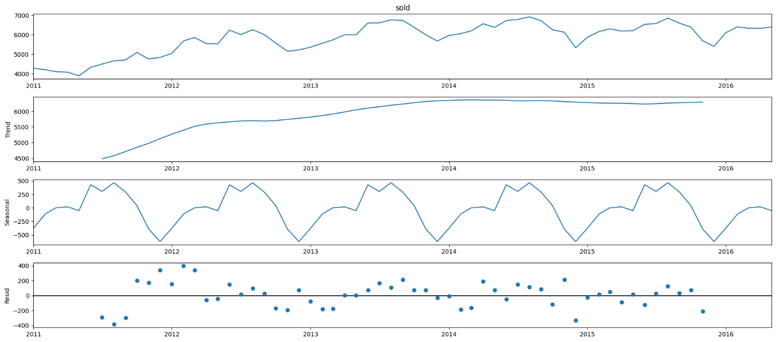

***Figure 74:*** *multi graph image**with graphs of Trend, Seasonal and Resid.*

***Inference:*** *There is a trend of growth in the graph of Trend up till 2014 and then plateauing between 2014 and 2016. In the seasonal graph there is a repetitive fluctuation over the course of 6 years. As for Resid the lowest plot goes below -400 and the highest plot goes above 400 over the period of 6 years*

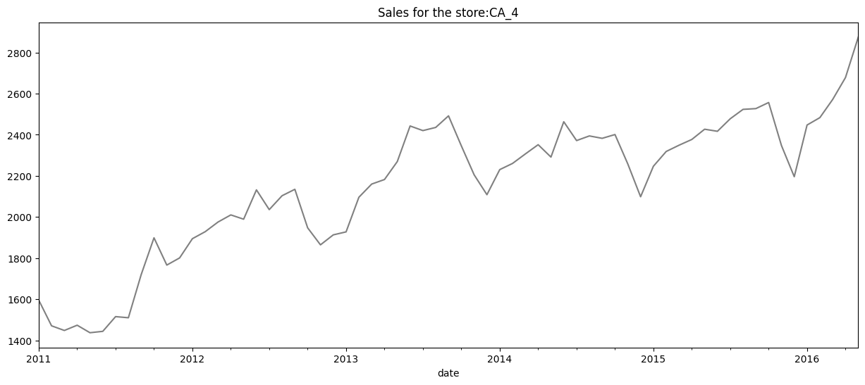

***Figure 75:*** *Sales**in the store CA_4 over a period of over 6 yrs*

***Inference:*** *It can be interpreted that there is a growth in sales from 2011 to 2016 with major drops between 2012 and 2016.*

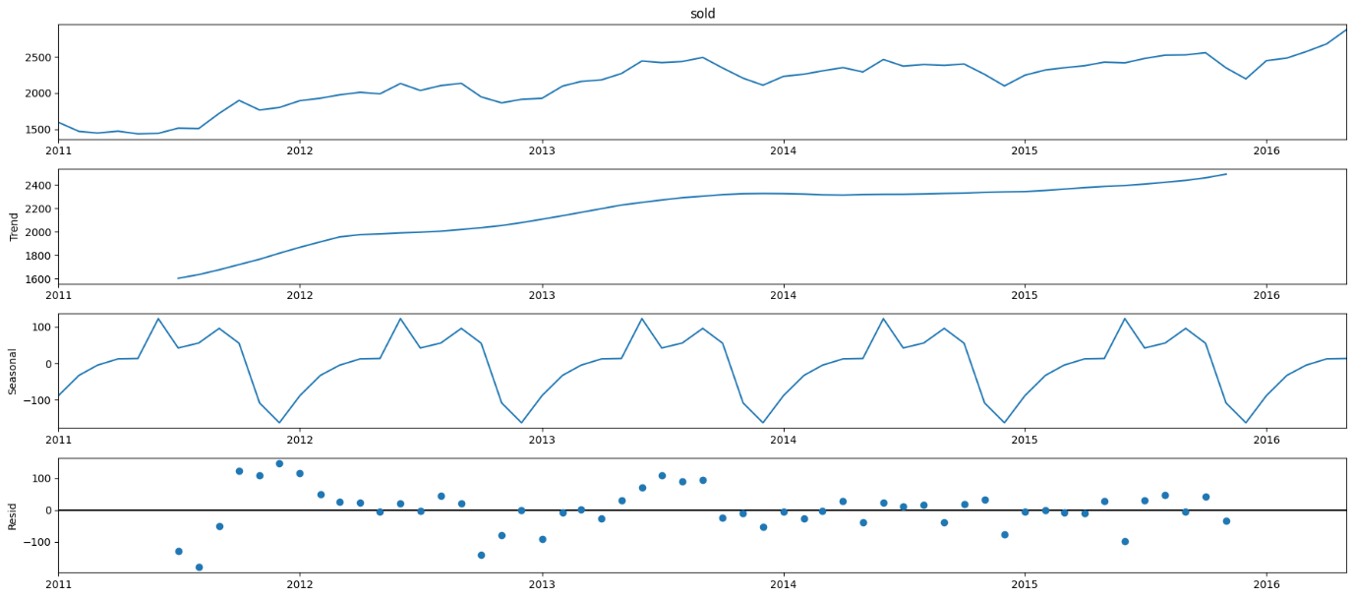

***Figure 76:*** *multi graph image**with graphs of Trend, Seasonal and Resid.*

***Inference:*** *There is a trend of growth in the graph of Trend. In the seasonal graph there is a repetitive fluctuation over the course of 6 years. As for Resid the lowest plot goes below -100 and the highest plot goes above 100 over the period of 6 years*

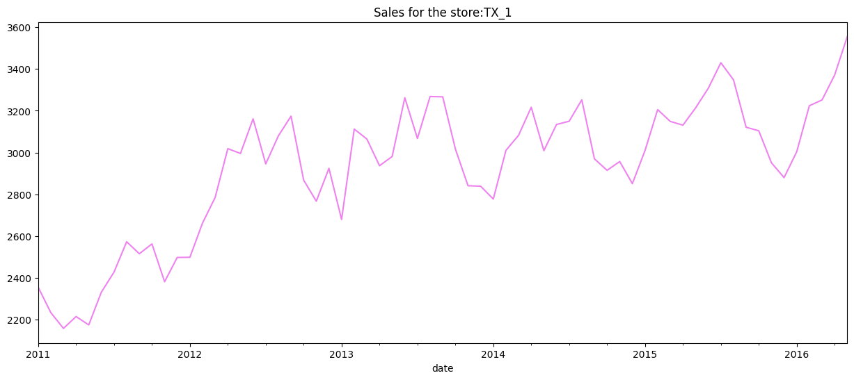

***Figure 77:*** *Sales**in the store TX_1 over a period of over 6 yrs*

***Inference:*** *It can be interpreted that there is a growth in sales from 2010 to 2016 with major drops between 2013 and 2016.*

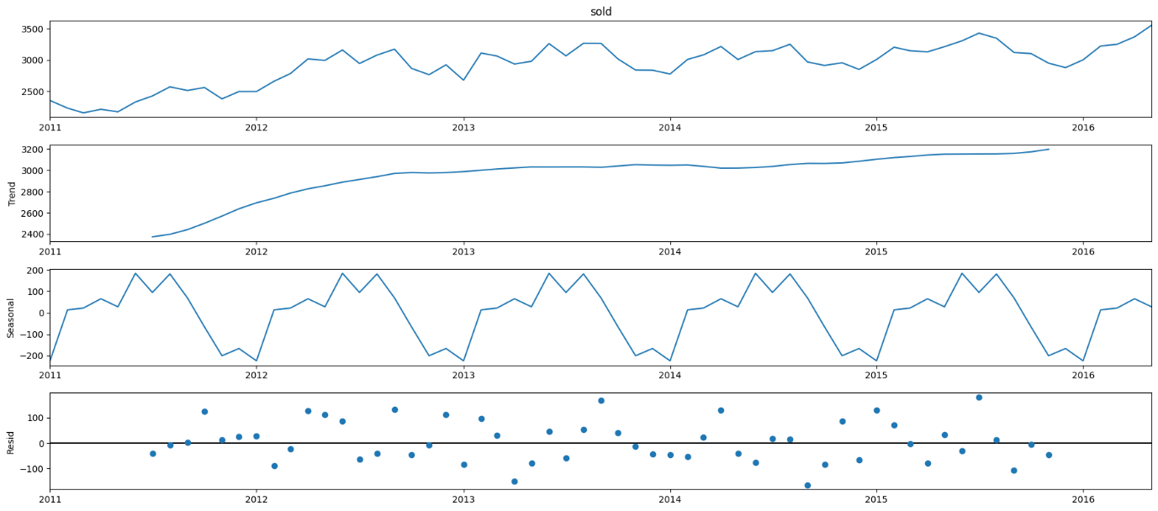

***Figure 78:*** *multi graph image**with graphs of Trend, Seasonal and Resid.*

***Inference:*** *There is a trend of growth in the graph of Trend. In the seasonal graph there is a repetitive fluctuation over the course of 6 years. As for Resid the lowest plot goes below -100 and the highest plot goes above 100 over the period of 6 years*

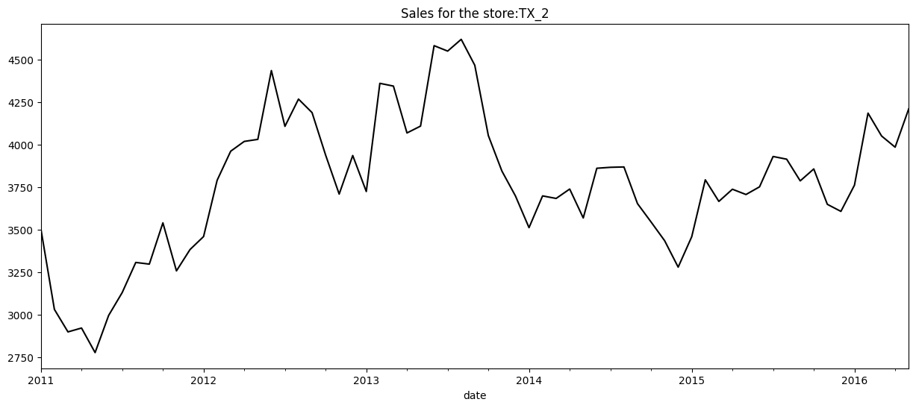

***Figure 79:*** *Sales**in the store TX_1 over a period of over 6 yrs*

***Inference:*** *It can be interpreted that there is a growth in sales from 2010 to 2016 with major drops and peaks between 2013 and 2016.*

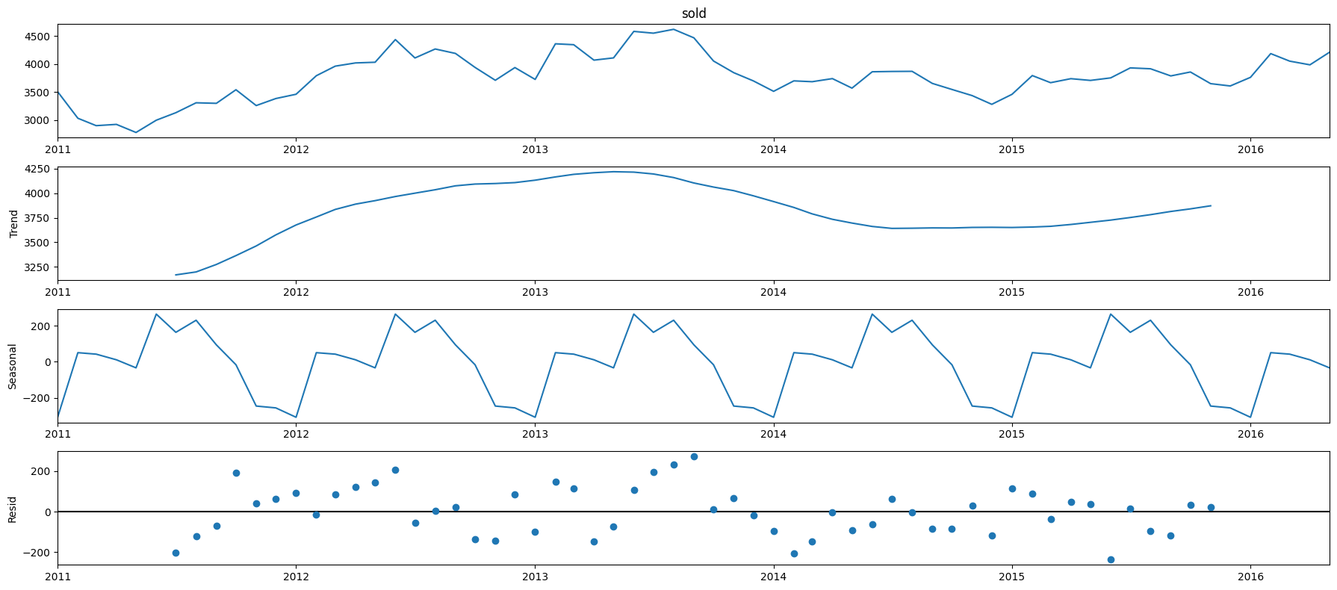

***Figure 80:*** *multi graph image**with graphs of Trend, Seasonal and Resid.*

***Inference:*** *There is a trend of growth in the graph of Trend till mid of 2013 and then drops to 3750 around mid of 2014 then there is a slight growth. In the seasonal graph there is a repetitive fluctuation over the course of 6 years. As for Resid the lowest plot goes below -200 and the highest plot goes above 200 over the period of 6 years*

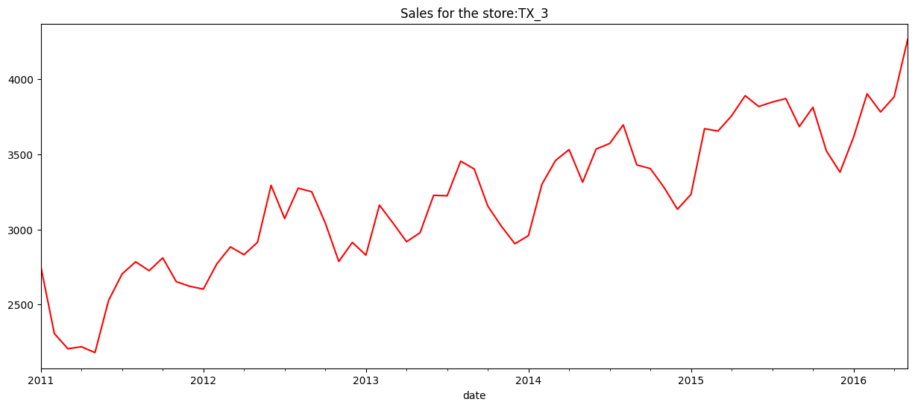

***Figure 81:*** *Sales**in the store TX_2 over a period of over 6 yrs*

***Inference:*** *It can be interpreted that there is a growth in sales from 2011 to 2016 with major drops and peaks between 2013 and 2016.*

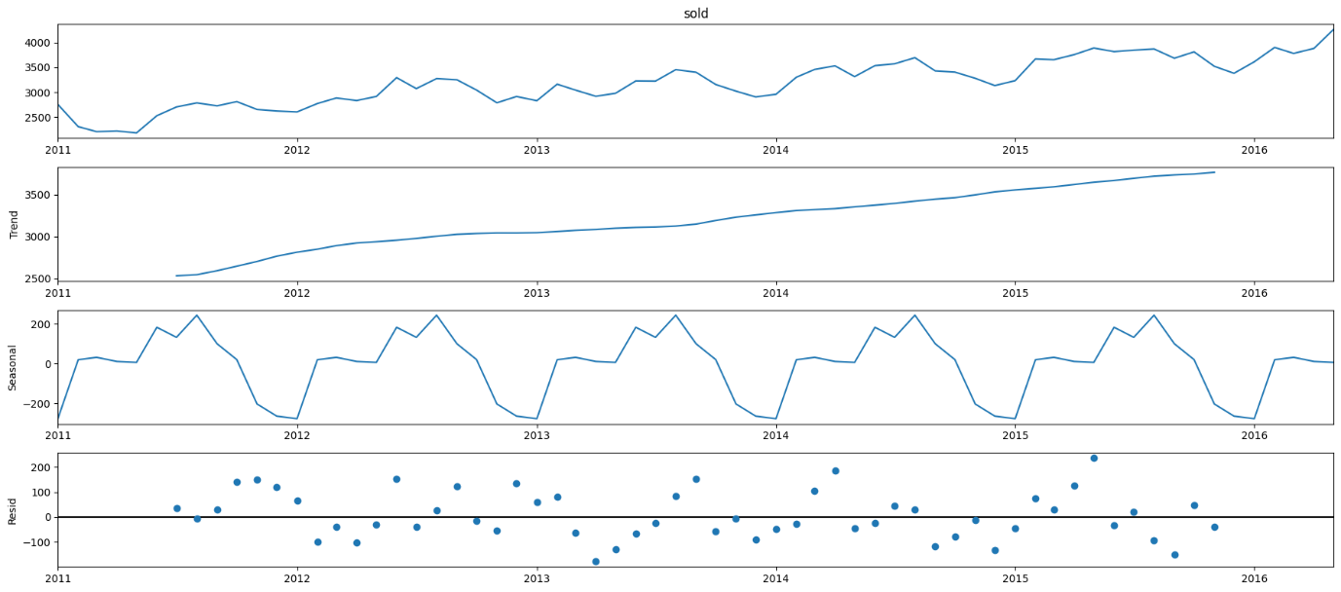

***Figure 82:*** *multi graph image**with graphs of Trend, Seasonal and Resid.*

***Inference:*** *There is a trend of growth in the graph of Trend. In the seasonal graph there is a repetitive fluctuation over the course of 6 years. As for Resid the lowest plot goes below -100 and the highest plot goes above 100 over the period of 6 years*

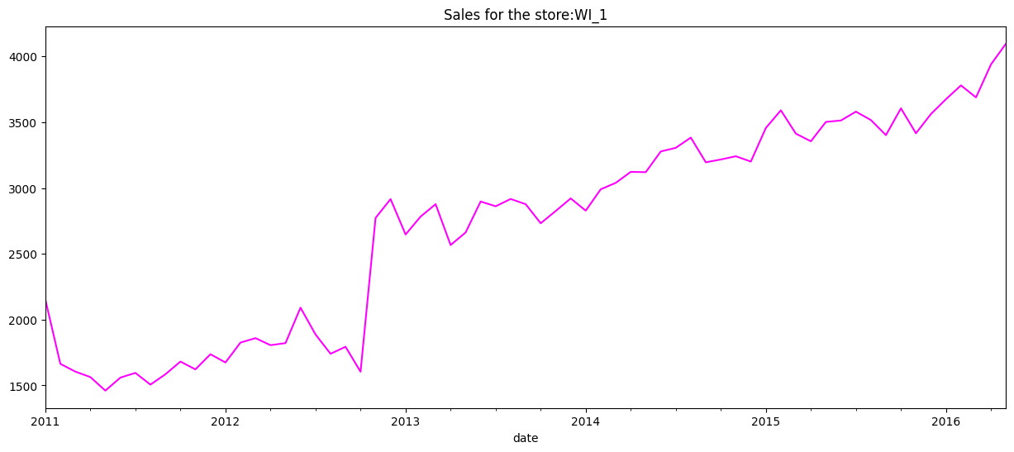

***Figure 83:*** *Sales**in the store WI_1 over a period of over 6 yrs*

***Inference:*** *It can be interpreted that there is a growth in sales from 2011 to 2016 with major drop and peaks between 2012 and 2013.*

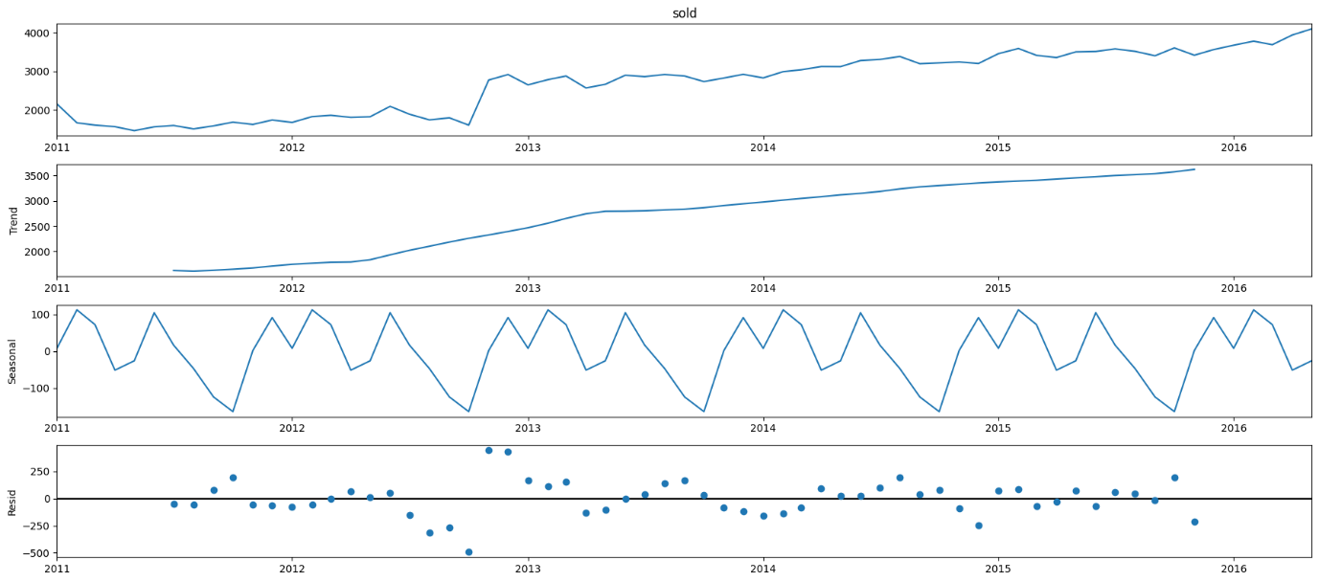

***Figure 84:*** *multi graph image**with graphs of Trend, Seasonal and Resid.*

***Inference:*** *There is a trend of growth in the graph of Trend. In the seasonal graph there is a repetitive fluctuation over the course of 6 years. As for Resid the lowest plot goes below -500 and the highest plot goes above 250 over the period of 6 years*

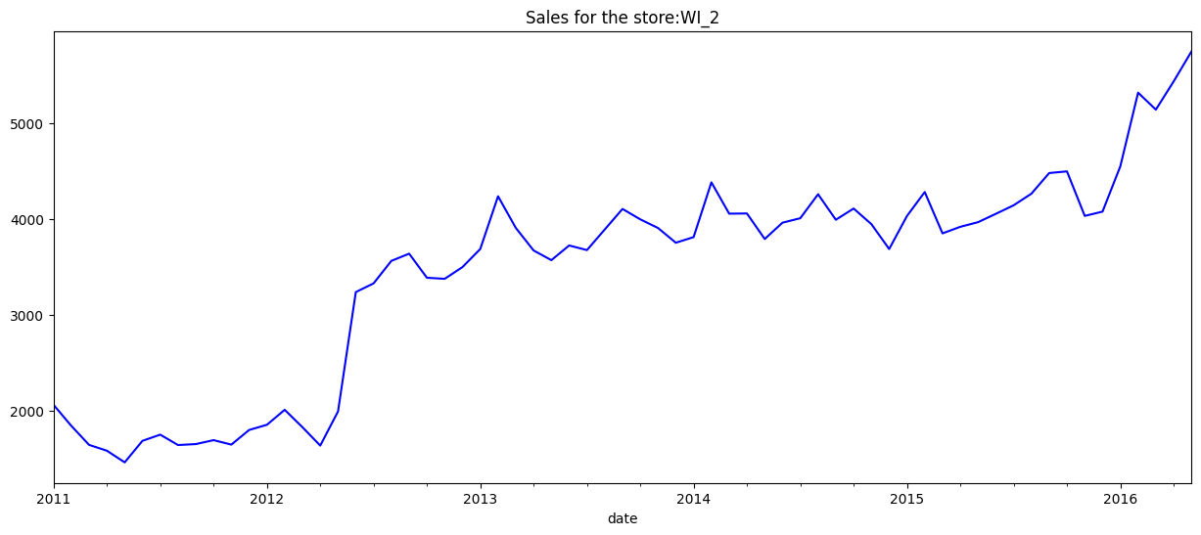

***Figure 85:*** *Sales**in the store WI_1 over a period of over 6 yrs*

***Inference:*** *It can be interpreted that there is a growth in sales from 2011 to 2016 with major drop and peaks between 2012 and 2014.*

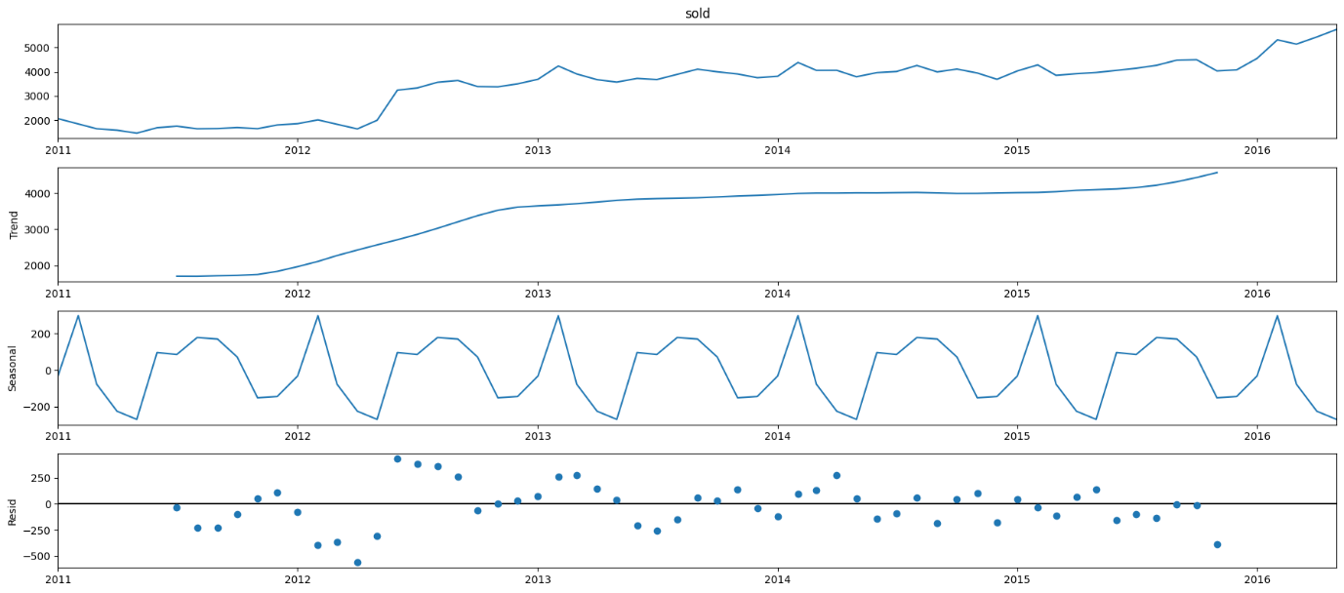

***Figure 86:*** *multi graph image**with graphs of Trend, Seasonal and Resid.*

***Inference:*** *There is a trend of growth in the graph of Trend. In the seasonal graph there is a repetitive fluctuation over the course of 6 years. As for Resid the lowest plot goes below -500 and the highest plot goes above 250 over the period of 6 years*

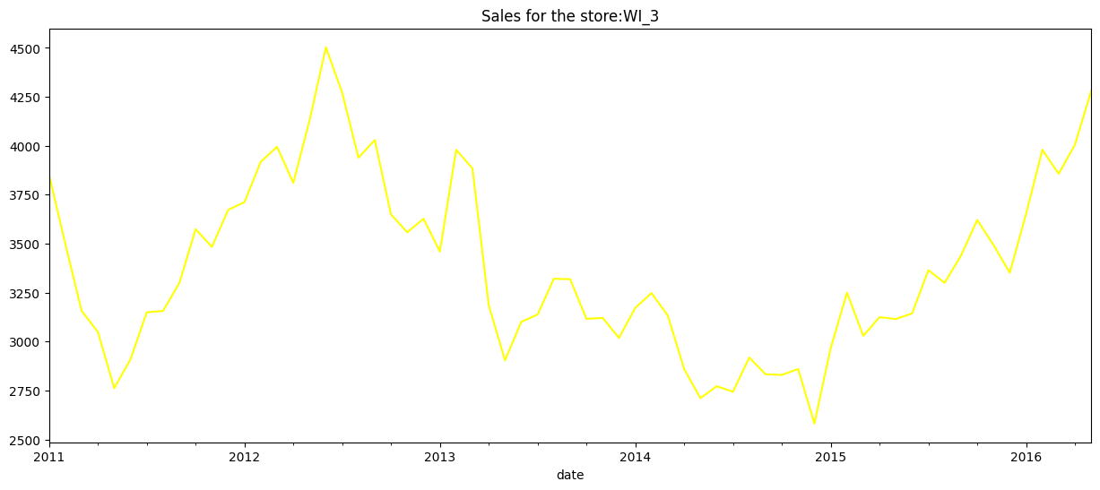

***Figure 87:*** *Sales**in the store WI_1 over a period of over 6 yrs*

***Inference:*** *It can be interpreted that there is a major fluctuation in sales from 2011 to 2016 with major drop around 2015 and peak in the mid-2012..*

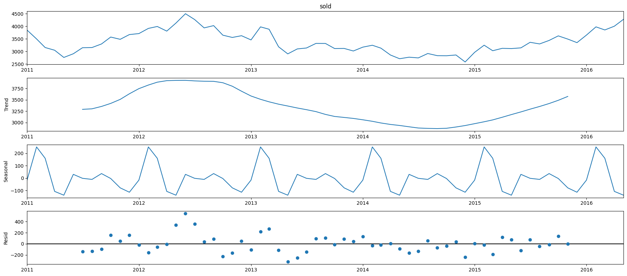

***Figure 88:*** *multi graph image**with graphs of Trend, Seasonal and Resid.*

***Inference:*** *There is a trend of fluctuation in the graph of Trend with peak in 2012 and drop in around 2015. In the seasonal graph there is a repetitive fluctuation over the course of 6 years. As for Resid the lowest plot goes below -200 and the highest plot goes above 400 over the period of 6 years*

#### *5.2*.4 Feature Engineering

#### ARIMA without any external features

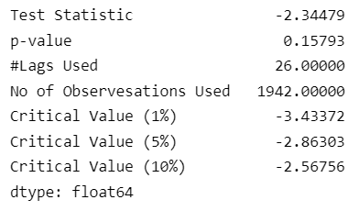

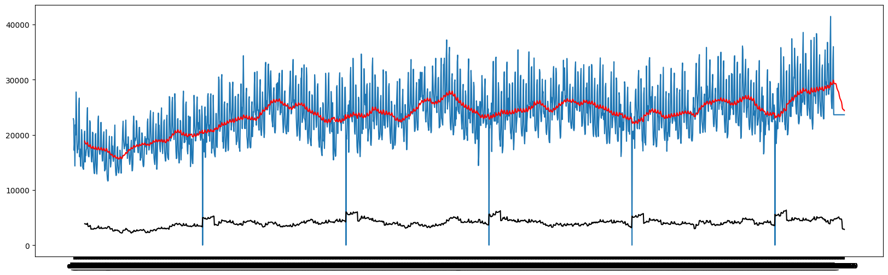

***Figure 89:*** *Sales over time with mean*

***Inference:*** We can observe that Test Statistic is not below the 1% of the Critical value. So, Series is not stationary.

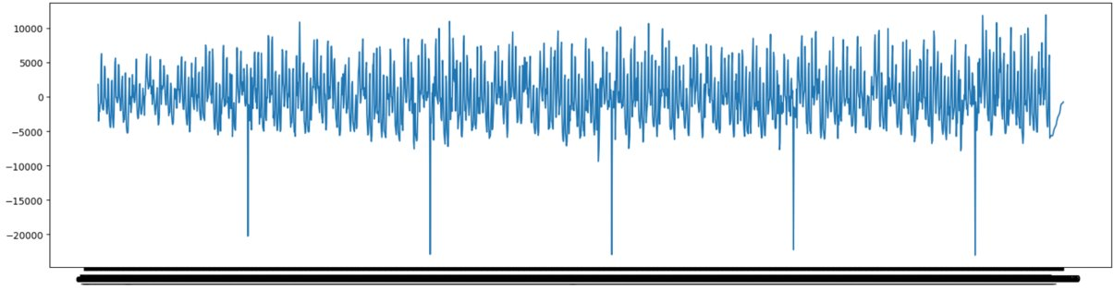

***Figure 90:*** *Sales over time with first differnece*

***Inference:*** We can observe that Test Statistic is way less than 1% of critical value. So, we can conclude that the above Series is 99% stationary.

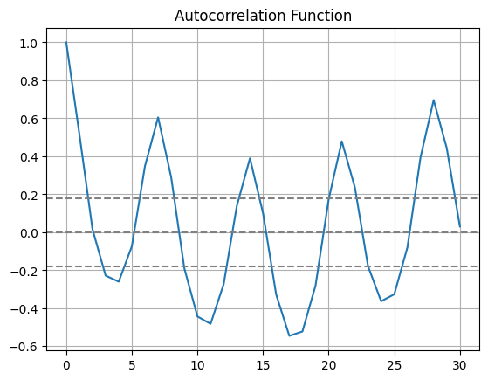

***Figure 91:*** *Figure of Autocorrelation Fucntion*

***Inference:*** Here, the function cross upper confident value between 1 and 2. Hence chose 2 as p for ARIMA

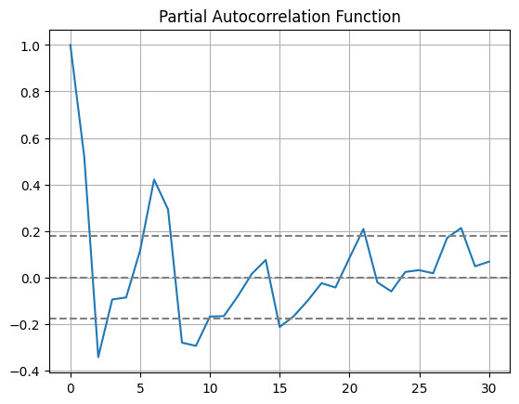

***Figure 92:*** *Image of a graph of Partial Autocorrelation Function*

***Inference:*** Partial Autocorrelation function drops to 0 when value is between 1 and 2. choose 2 as q value

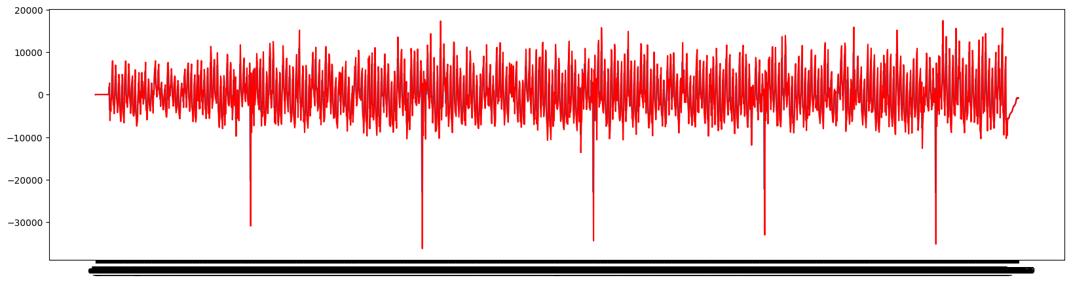

***Figure 93:*** *Prediction Result*

***Inference:*** *It can be inferred that the majority of the graph point stays between 10000 and -10000 with 5 major drops that go to around -30000*

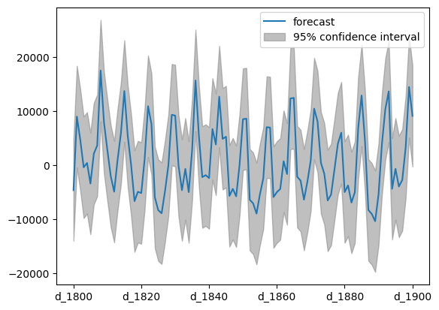

***Figure 94:*** *The graph of the forecast and the confidence interval among different d_xxxx*

***Inference:*** *it can be inferred that forecast plot stays between 10000 and -10000 with some peaks reaching around 20000. The confidence interval goes through major fluctuation all over the graph and peaks above 20000 and drops to around -20000*

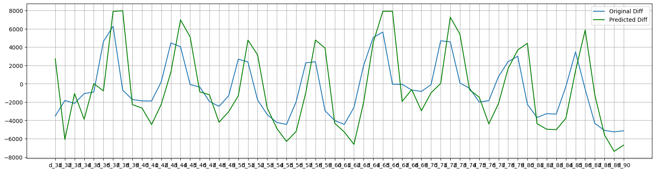

***Figure 95***

***Inference:*** *It can be inferred that there are multiple peaks and drops all over the graph. Original Diff peaks at around 6000and drops in at around -4000. Predicted Diff peaks at around 8000 and drops at around -6000 to -8000.*

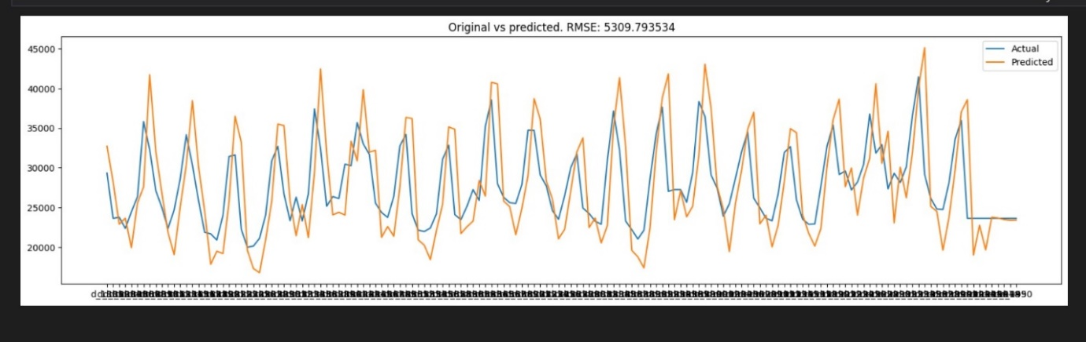

***Figure 96*** *Original vs Predicted: RMSE*

***Inference:*** *There are multiple peaks and drops in this plot graph with predicted peaking at around 45000 and dropping at below 20000 and actual peaking at around 40000 and dropping at around 20000*

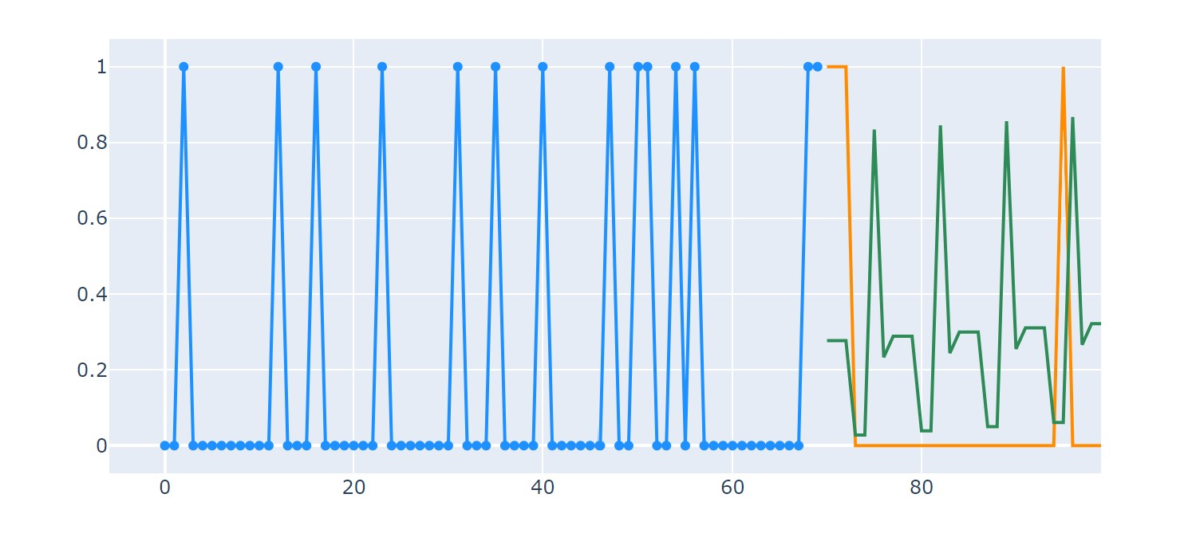

***Figure 97:****Arima with external features*

***Inference:*** *It can be inferred that there are multiple peaks and drops all over the graph.*

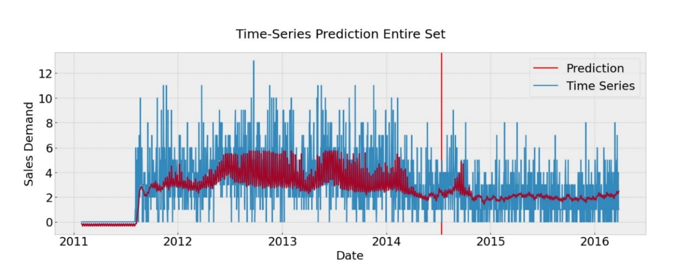

***Figure 98:*** *LSTM without any external features*

***Inference:*** *It can be inferred that there are multiple peaks and drops all over the graph. Most of the plotting of Prediction stays within the range of 2 to 6 and the plotting of Time Series is all over the place ranging from 0 to 12.*

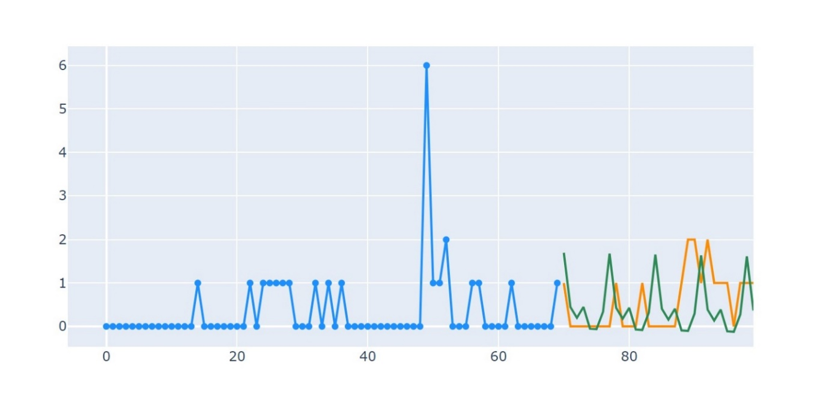

***Figure 99:*** *LSTM with external features*

***Inference:*** *It can be inferred that there are multiple peaks and drops all over the graph.*

|  |  |  |  |
| --- | --- | --- | --- |
|  | **Food: RMSE score** | **Hobbies: RMSE score** | **Household: RMSE score** |
| **ARMIA without external features** | 5309.79 | 5634.12 | 4541.43 |
| **ARIMA with external features** | 4987.34 | 4679.90 | 4652.76 |

|  |  |
| --- | --- |
|  | **RMSE Score** |
| **LSTM without external features** | 5920.76 |
| **LSTM with external features** | 4029.46 |

### 5.3 Colab Link

*<https://colab.research.google.com/drive/1VFrbGlotNN4AmAYxldNU2q-FCKogQsXQ?usp=sharing>*

# C) Sprint 3

## 6. Dataset 2

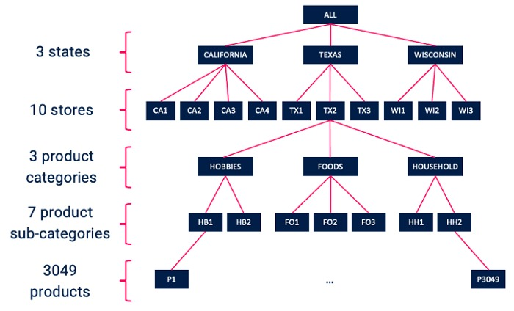

***Figure 100:*** *Tree representation of the dataset of sales in stores of the three states.*

### 6.1 Deploy the machine learning model using Streamlit

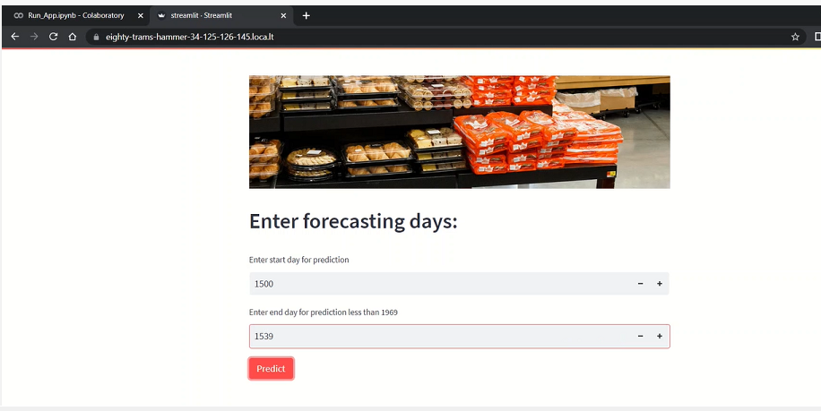

***Figure 101:*** *Streamlit App Deployment*

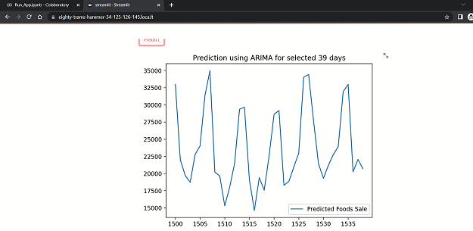

***Figure 102:*** *Streamlit Deployment Prediction*

### 6.2 Product Segmentation

#### 6.2.1 Task A)

***Use first year data of Household category to create ABC Analysis and interpret the graph.***

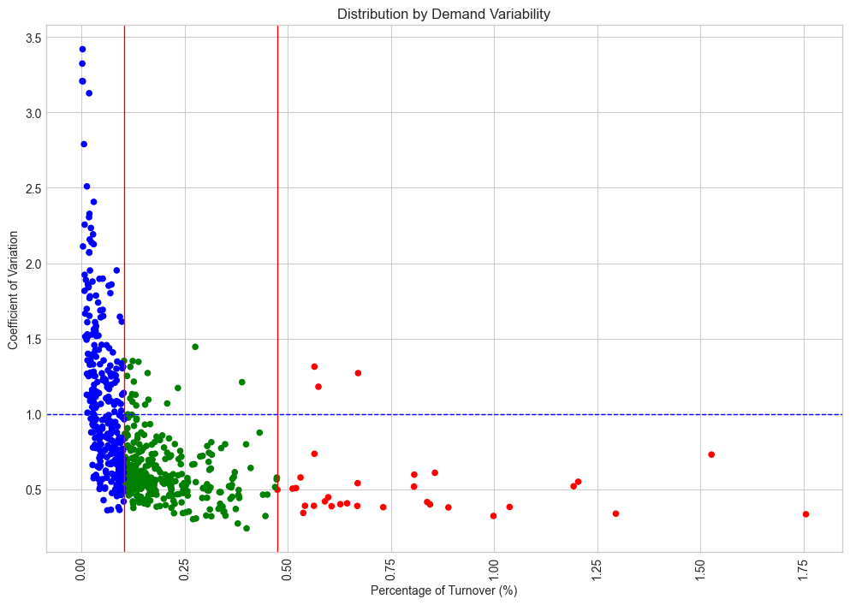

***Figure 103:*** *A scatter graph plotting Coefficient of Variation against Percentage of Turnover (%)*

***Inference****: It is evident that the points are highly concentrated within the range of 0-1.5 for Coefficient of Variation and 0-0.25 for Percentage of Turnover (%)*

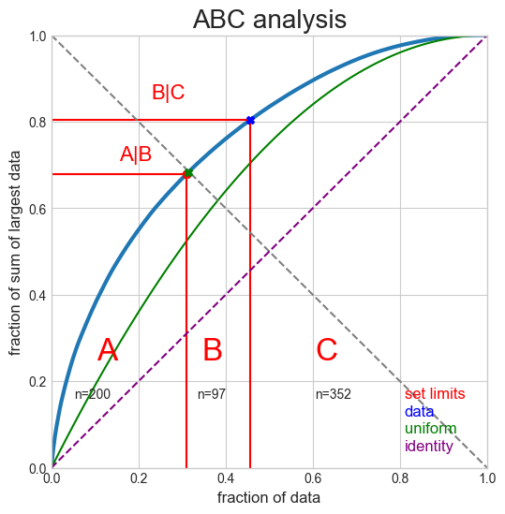

***Figure 104:*** *ABC Analysis graph plot*

#### 6.2.2 Task B)

***How stable is the customers’ demand? (Coefficient of Variation)***

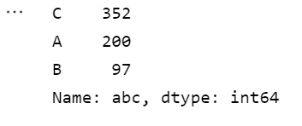

There is high variability in class C customers and lowest in class B customers.

#### 6.2.3 Task C)

***Discuss a few initiatives and recommendations for improving the retail business for dataset_02.***

##### Daily sales

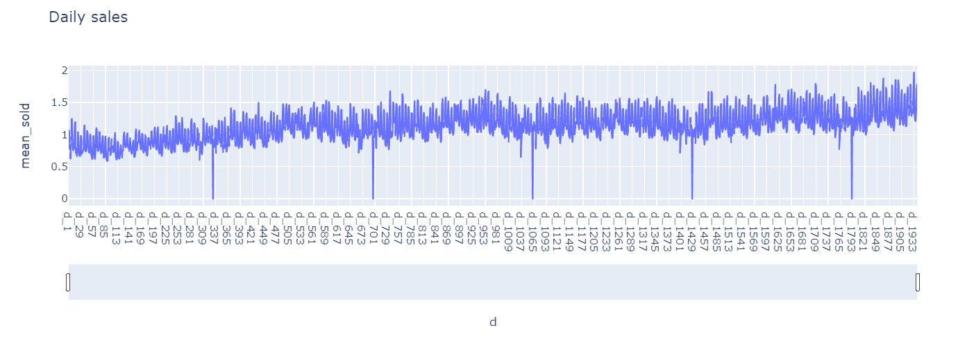

***Figure 105:*** *Plotted graph of mean_sold against the multiple days’ ids*

***Inference:*** *It can be inferred here that on days like d_331, d_697, d_1062, d_1427, d_1792 the sales drastically drop down to almost zero, and coincidentally we can also see that it is Christmas on those days.*

##### Total Sales on Christmas day in each Store

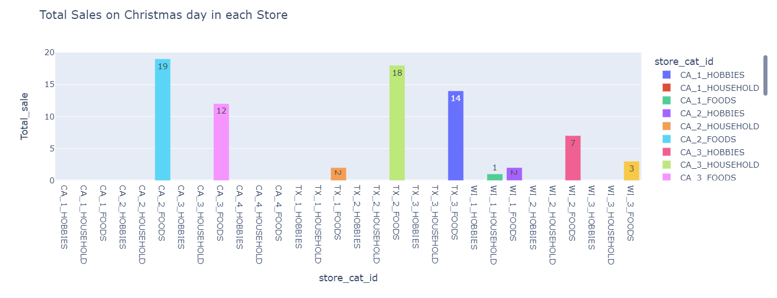

***Figure 106:*** *Bar graph of the Total sales on the day of Christmas in each store in each product category.*

***Inference****: As we can see that at Christmas the store wise sales by each category is zero except for food with CA_2 being the highest and Wi_1 being the lowest.*

***Our-Suggestion****: To increase sales on Christmas we can give out large discounts on food products like: "20% flat discount on every food product purchased on Christmas day." Or we can make discounts on other products to increase the revenue from those products.*

##### Total Sales by state

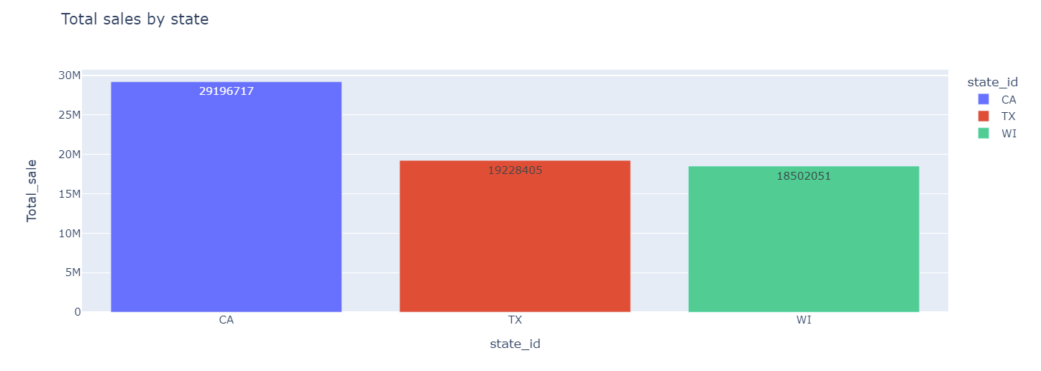

***Figure 107:*** *Bar graph of the total sales in each state.*

***Inference****: Here it can be seen that California has the highest sales followed by Texas and then at last Wisconsin. The main reason being the fact that California has the highest population followed by Texas and Wisconsin.*

***Our Suggestion****: To increase the sales, we can have a state-wise view of which products are selling more in each state and we can maximize the profits based on the highest selling product by having a greater supply of those products in that specific state. So, we need a closer look at sales by each product in each state.*

##### Total sales store-wise

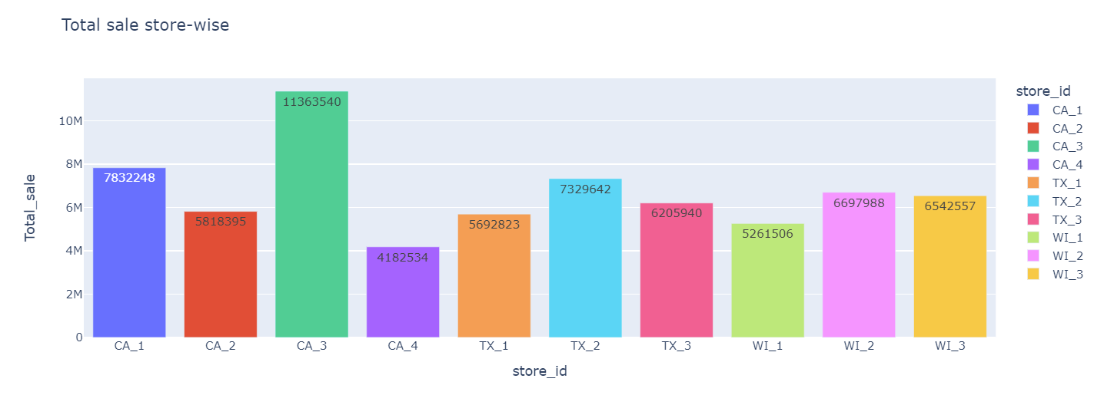

***Figure 108:*** *Bar graph of the sales of stores in each state*

***Inference****: As we can see that CA_3 has the highest sales among all other stores whereas CA_4 is the lowest in terms of sales.*

***Our Suggestion:*** *More discounts on items that are highest selling in CA_4 should be given to increase the sales of those items, moreover we need to supply products that are highest selling in CA_3 by maximizing the revenue. A similar strategy should be taken for every store.*

##### Total Sales of by category

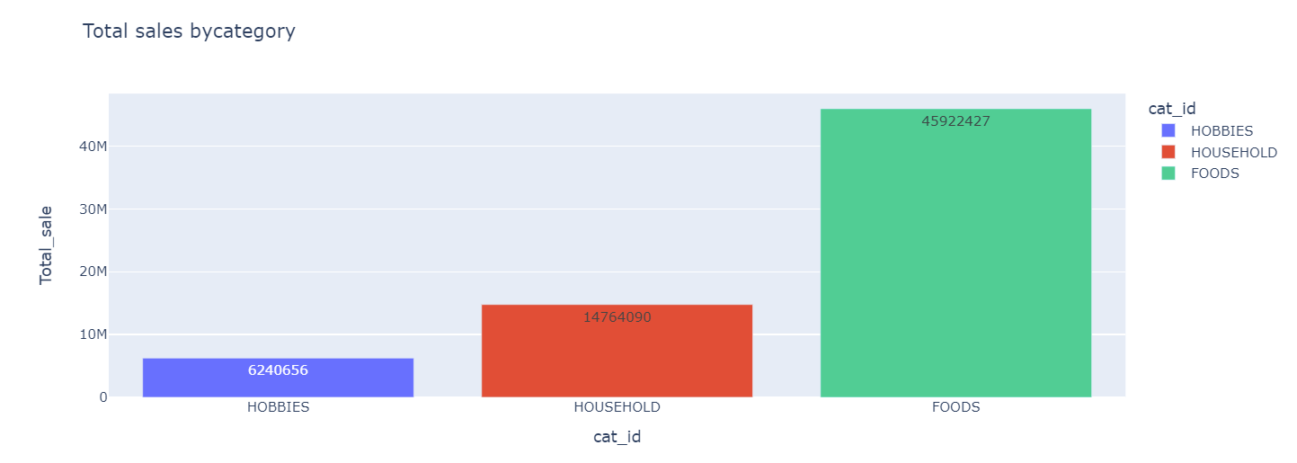

***Figure 109:*** *Bar graph of sales by category (Hobbies, Households, Foods)*

***Inference****: It is very evident from the graph above that Food items are the highest selling products. However, Hobbies related products are the lowest with respect to selling.*

***Our Suggestion:*** *Greater discounts should be laid on hobby-related products to increase the sales of those products and better supplies should be made for food-related items.*

##### Sales based on Product Category in each State

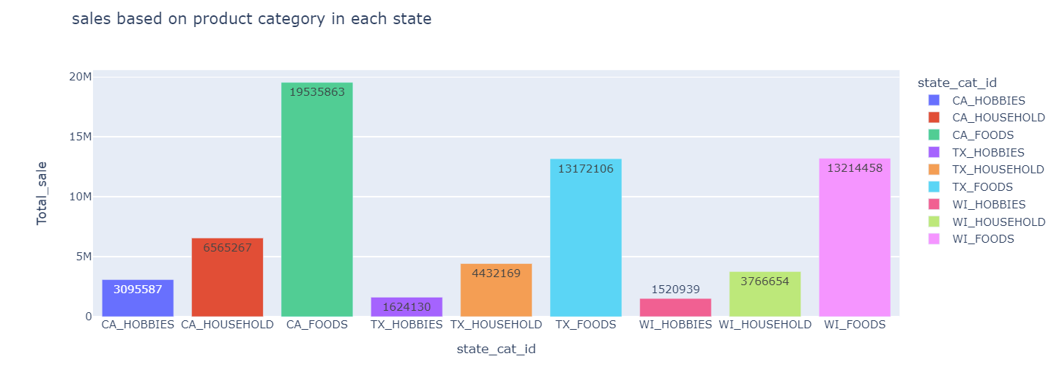

***Figure 110:*** *Bar graph of the Sales divided based on product category in each state.*

***Inference****: Overall, food items are sold more than anything else across all the three states.*

***Our Suggestion****: Greater supply of food related items should be made so that we can maximize the revenue and we need to decrease the prices of hobby related items so that we can increase the sales of those items.*

##### Sales by Weekdays

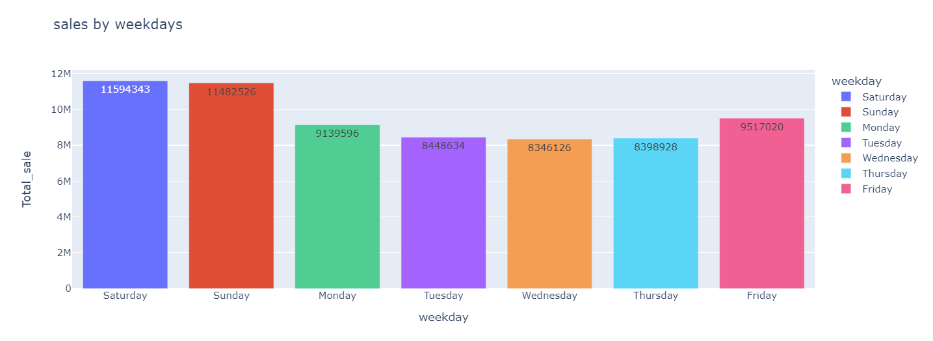

***Figure 111:*** *Bar graph of the sales of the stores by the weekdays.*

***Inference****: It’s clear from the graph above that Fridays, Saturdays and Sundays have higher sales when compared to other days of the week.*

***Our Suggestion****: Just like we have "happy hours" in many stores. We can give "happy Wednesdays" or "happy Tuesdays" to increase the sales on those days.*

##### Sales based on event_type_1

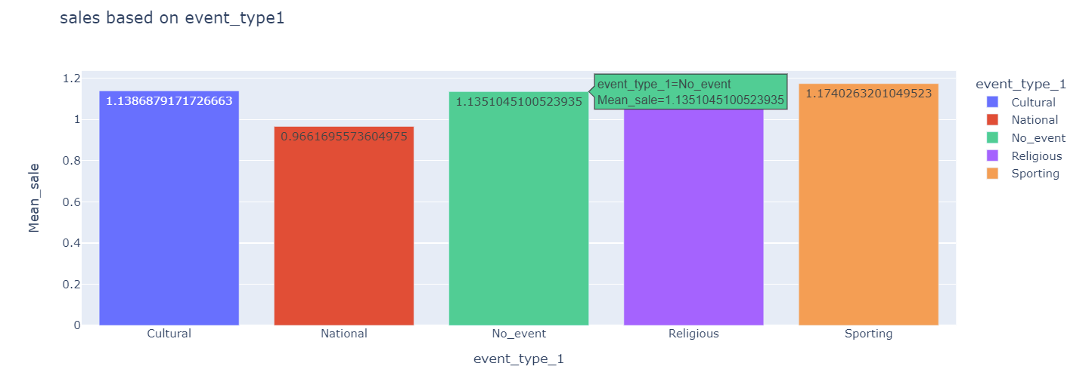

***Figure 112:*** *Bar graph based on the categories of the event types*

***Inference****: We can see that the sales are less on national holidays.*

***Our Suggestion****: We need to lower the prices of products, especially food related items on national holidays so that we can maximize the revenue. The sales are comparatively lesser on national holidays. This suggests us that we might have to focus on the parameters on which people show lesser spending trends on national holidays. Various factors such as the “open hours of the store”, “veteran staff availability” can be an influencing factor.*

##### Sales based on event_type_2

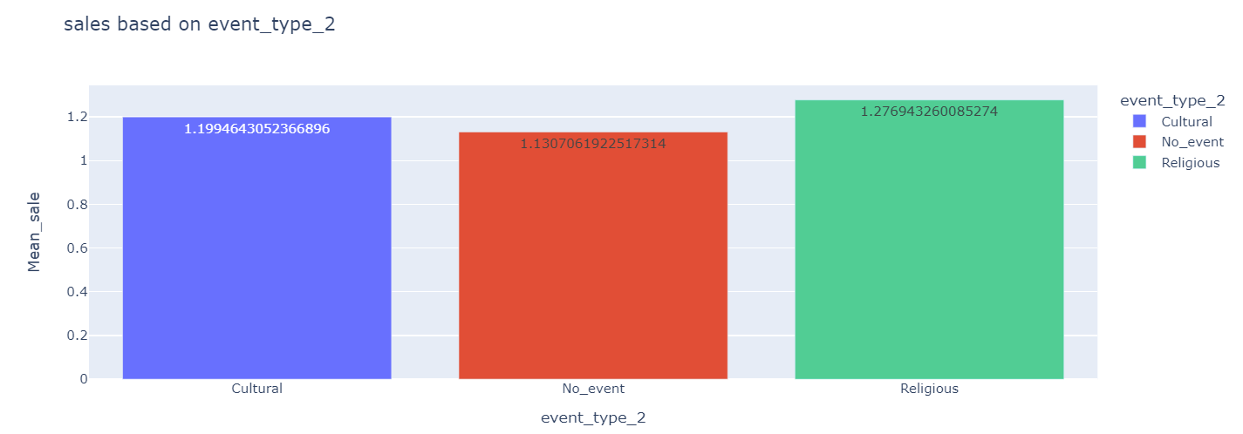

***Figure 113:*** *Bar graph based on the categories of the event types*

***Inference****: religious events affect the sales of products.*

***Our Suggestion****: greater supply should be made for products on religious events storewide.*

##### Effects of snap and no snap days on sales.

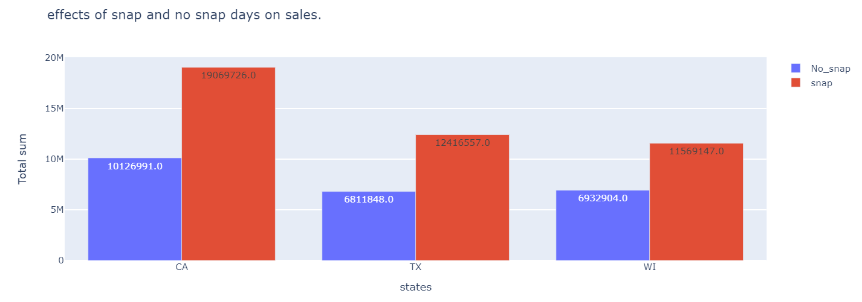

***Figure 114:*** *Bar graph representing the effects of the snap or no snap days on sales*

***Inference****: It can be seen that Snap days have higher sales as compared to non-snap days across all the states.*

***Our Suggestion:*** *More amount products should be made available on snap days as compared to non-snap days to maximize the revenue.*

### 6.3 Colab Link

*<*[*https://colab.research.google.com/drive/1FBtcUZ-alpuoOqlx-1p5ss07VV6Yl3z8?usp=sharing*](https://colab.research.google.com/drive/1FBtcUZ-alpuoOqlx-1p5ss07VV6Yl3z8?usp=sharing)*>*

## 7. Conclusion

* **Dataset 1:**
  + **Sprint 1:** There are high sales if any type of discount is given to customers and among all of them promotional discount is one to attract Customers. Size, Type of store are crucial factors in determining its weekly sales. Sales gets decreased when too hot or too freezing weather and increase in gas price. But Sales during holidays are more compared to non-holiday seasons, and Thanksgiving holiday sales are highest compared to other holiday sales.
  + **Sprint 2:** Linear regression performs best amongst all other regression models. All ensemble models perform better than neural network models.
* **Dataset 2:**
  + **Sprint 1:** Overall, Father’s Day has the highest spending based on dataset 2.
  + **Sprint 2:** The ARIMA prediction without external features is not stationary due to its high value of test statistics. The ARIMA prediction with external features is 99% stationary due to its low value of test statistics.
  + **Sprint 3:** We could see that the snap days have higher sales when compared to the non-snap days from the given dataset analysis. Even religious events seem to have an impact on the sales of products. On the other hand, sales on national holidays are pretty less.

We could see that the snap days have higher sales when compared to the non-snap days from the given dataset analysis. Even religious events seem to have an impact on the sales of products. On the other hand, sales on national holidays are pretty less. There are a couple of inferences made in the analysis on the areas where sales should be maximized.